**Local DNS Attack Lab**

**Task 1 - Configure the User Machine**

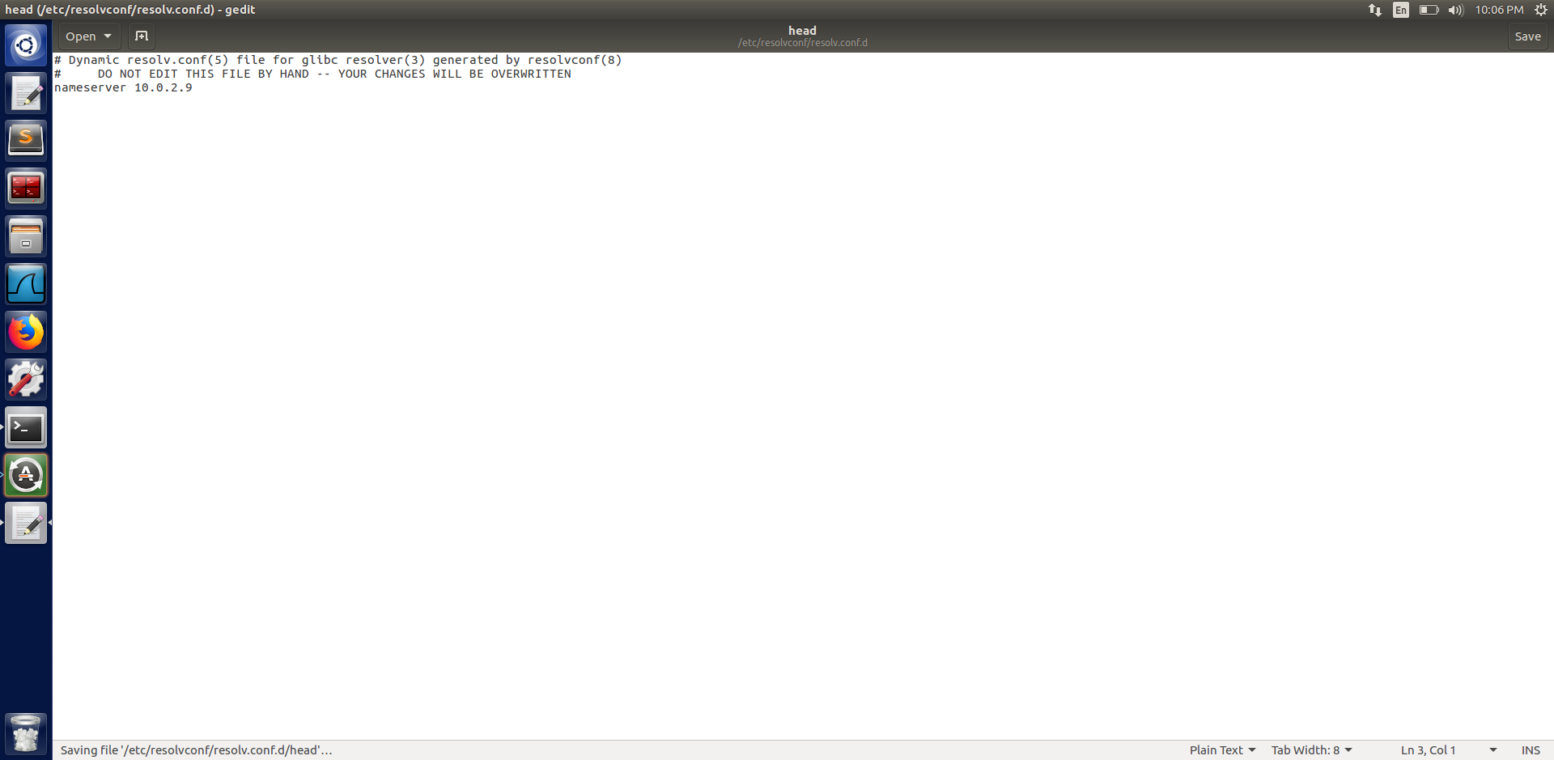

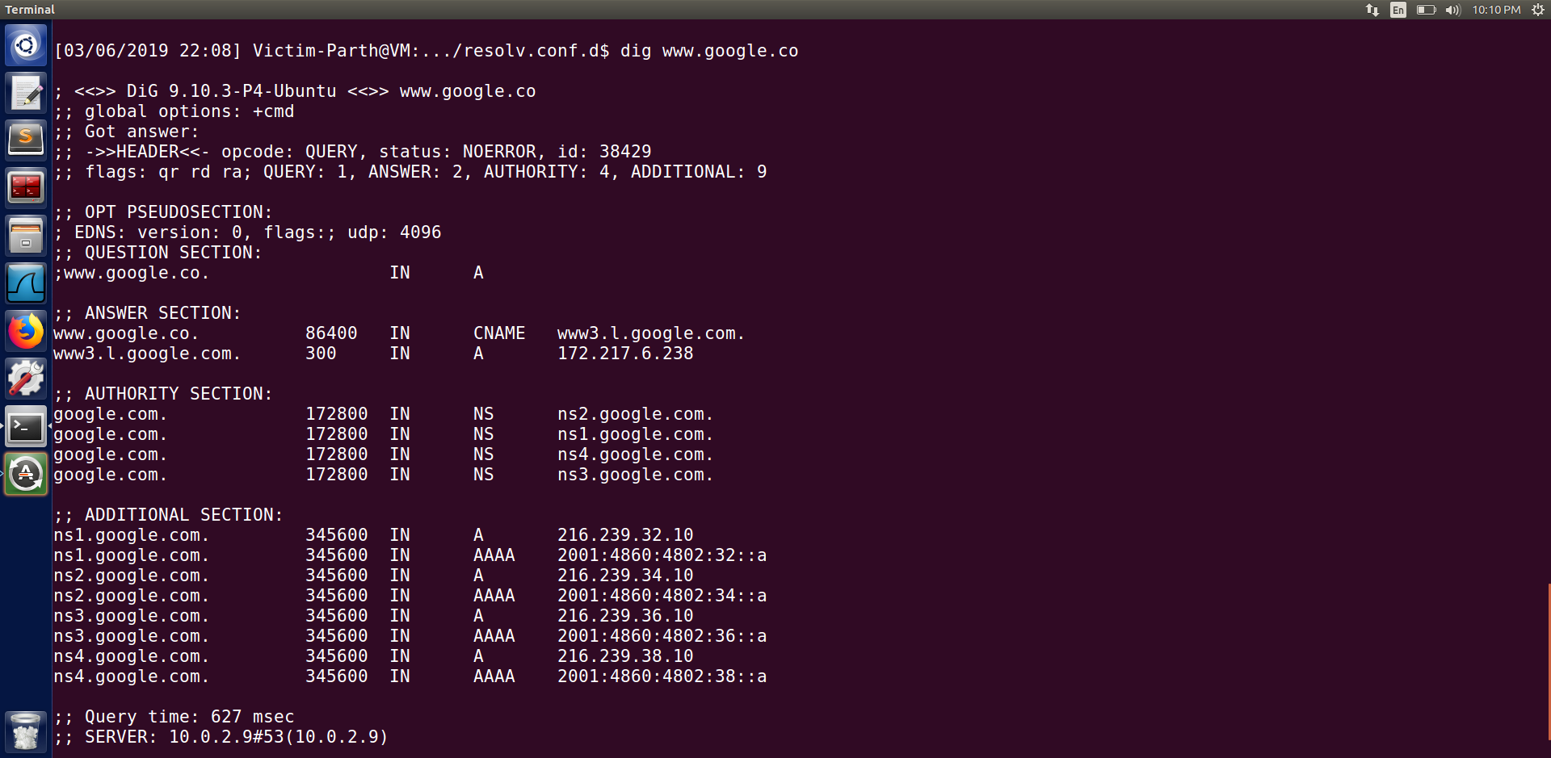

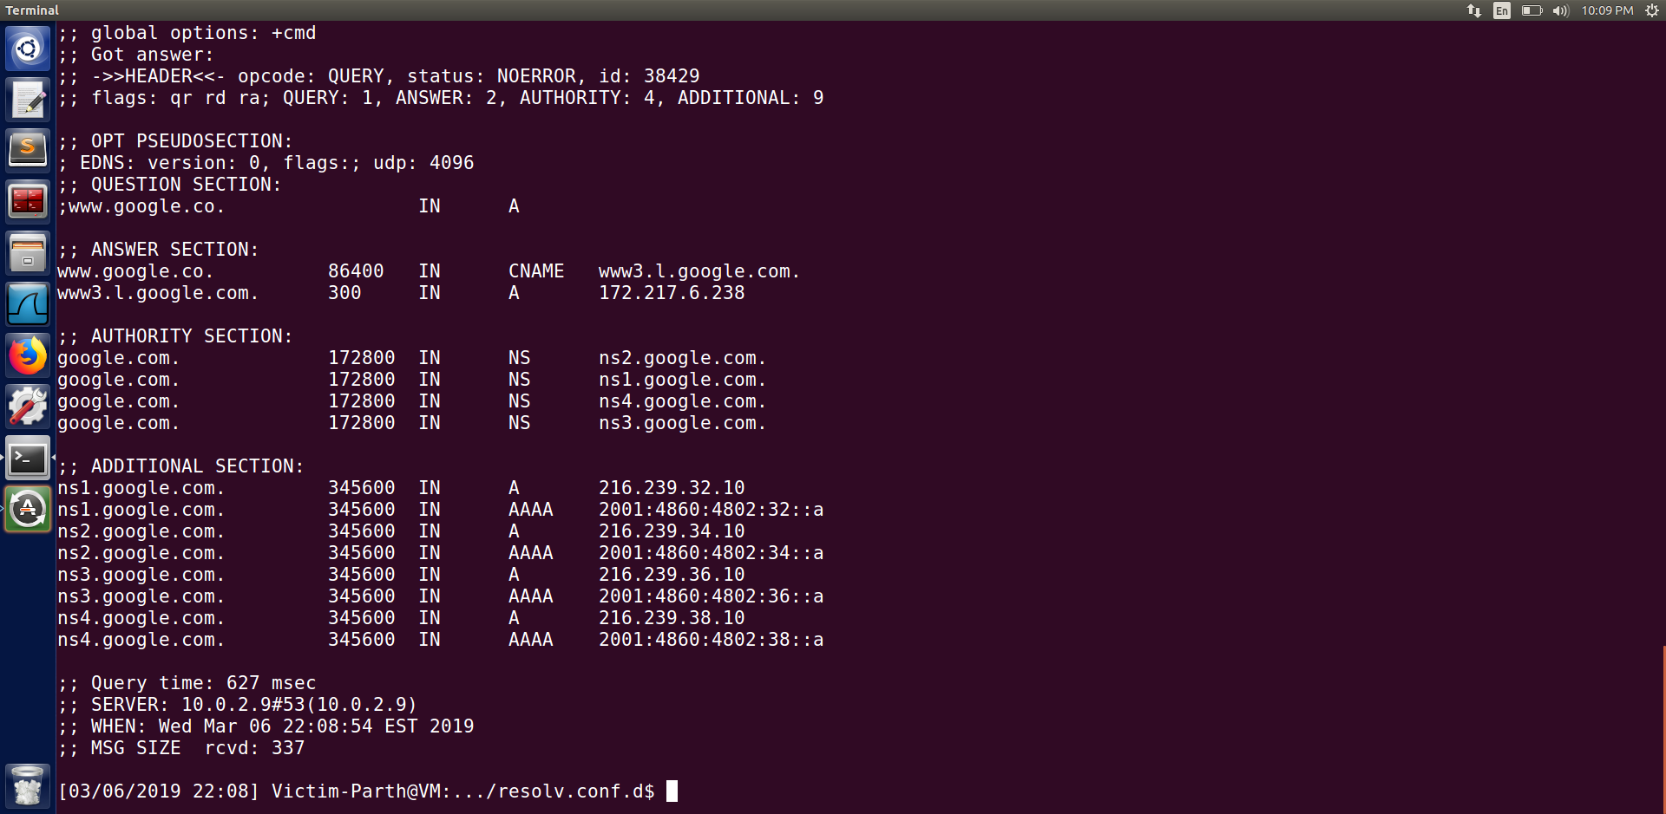

In this task we first added the name server 10.0.2.9 as the local DNS server in our user machine (10.0.2.7). When we execute this command it means that this server is used as the primary DNS server. To confirm that we were successful in executing our command we use the command ‘ dig [www.google.co](http://www.google.co)’. We can see from the above screenshot that in the SERVER section we get the IP of the local DNS server which is 10.0.2.9.

**Task 2 - Set up a Local DNS Server**

**Step 1 & 2 - Configure the BIND 9 server & Turn off DNSSEC.**

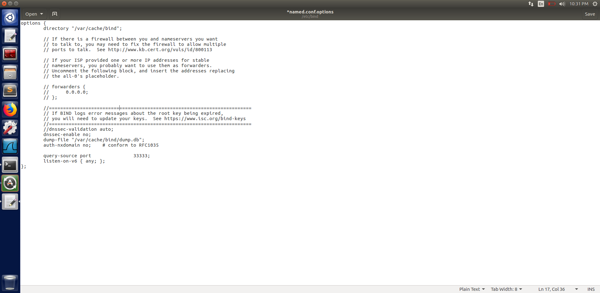

**Step 3 - Start DNS server**

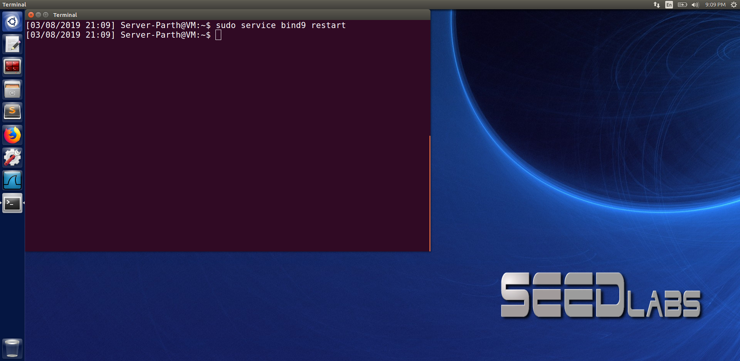

**Step 4 - Use the DNS server.**

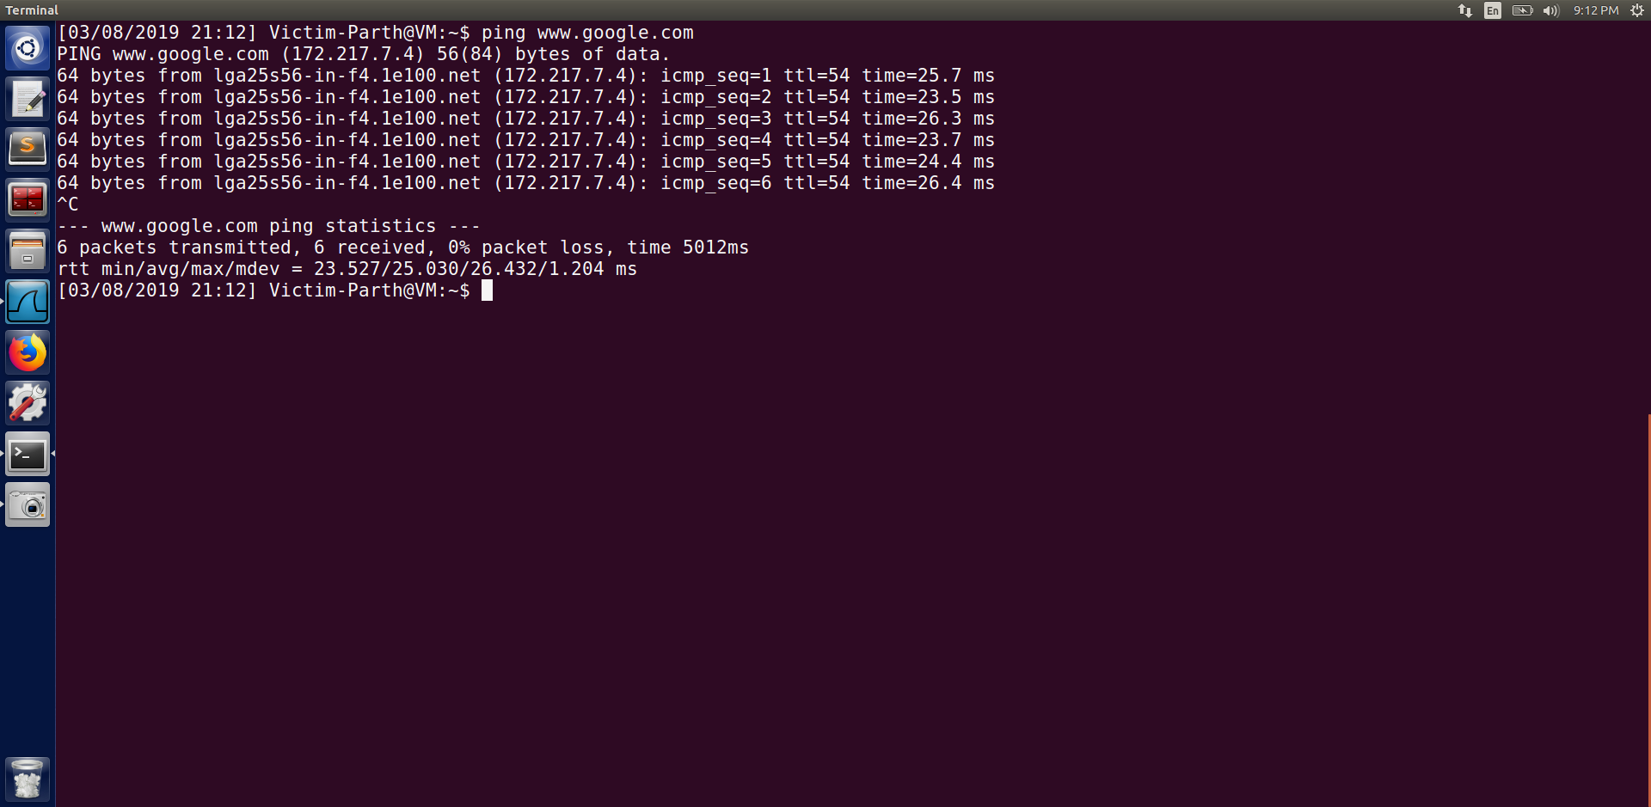

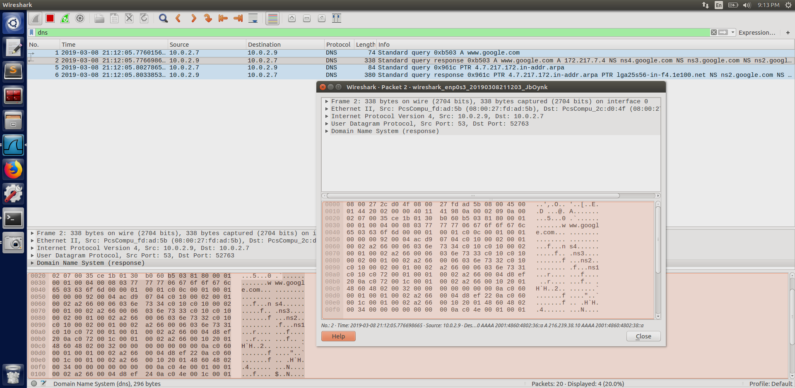

In this task we first configure the BIND 9 server. We add a dumpfile entry to the option block as seen in the 1st step of task 2. Then, we turn off the protection as it’s a countermeasure to protect against the spoofing attack.

In step 3 we start the DNS server as seen in the screenshot of Step 3 above. And in the final step we ping [www.google.com](http://www.google.com) from the client’s machine. We observe the packets on wireshark and we can see that the query first goes to the server (10.0.2.9) and is then forwarded. After that we check the cache of the server’s machine.

**Please also indicate when the DNS cache is used**

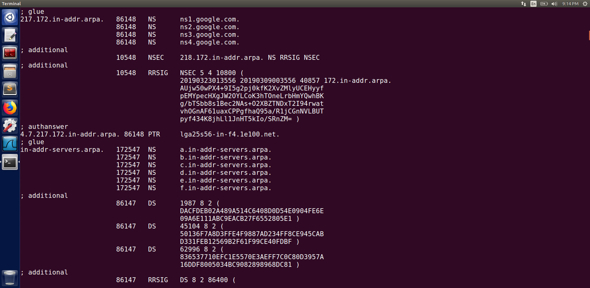

**Task 3 : Host a Zone in the Local DNS Server**

**Step 1: Create zones**

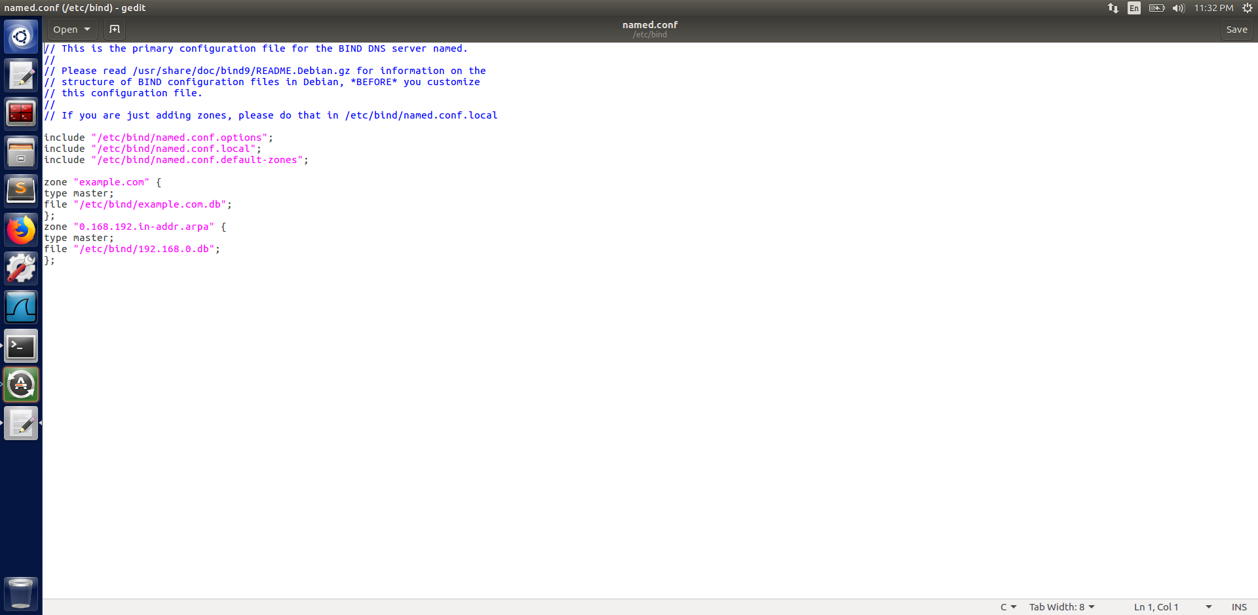

**Step 2 : Setup the forward lookup zone file**

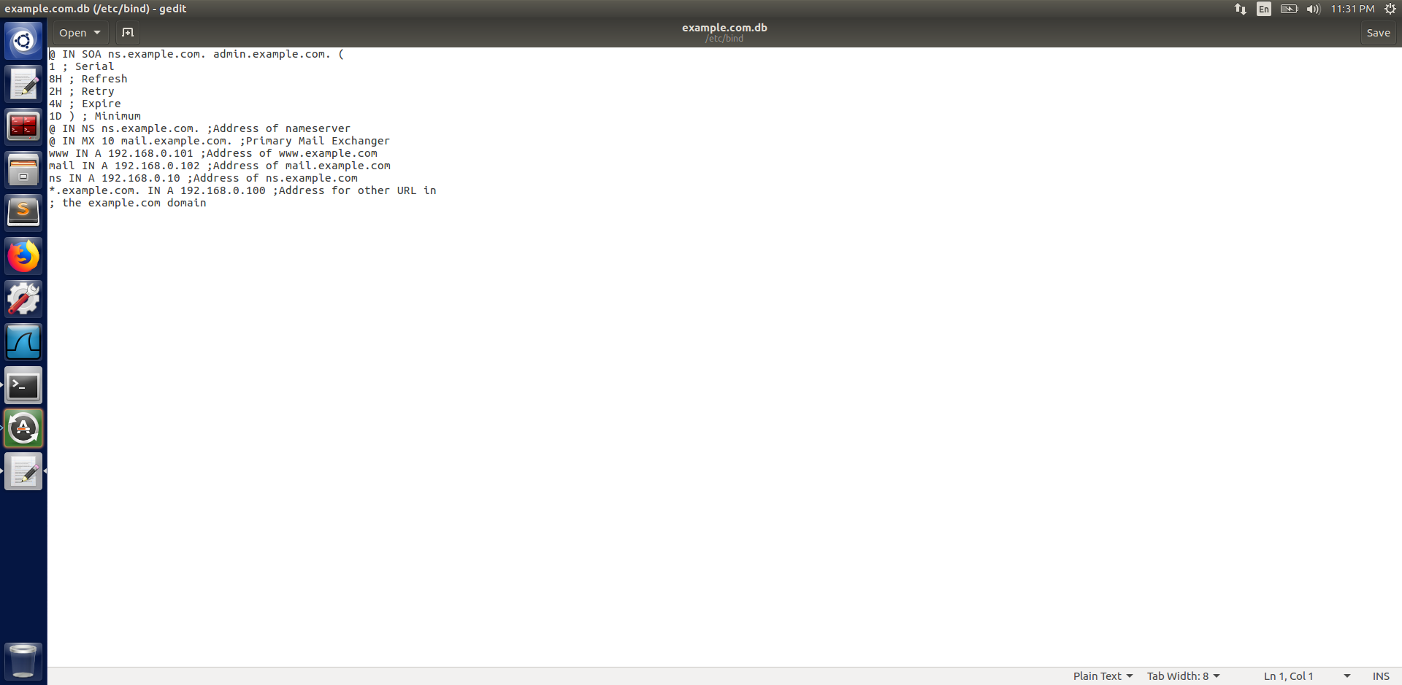

**Step 3 : Set up the reverse lookup zone file**

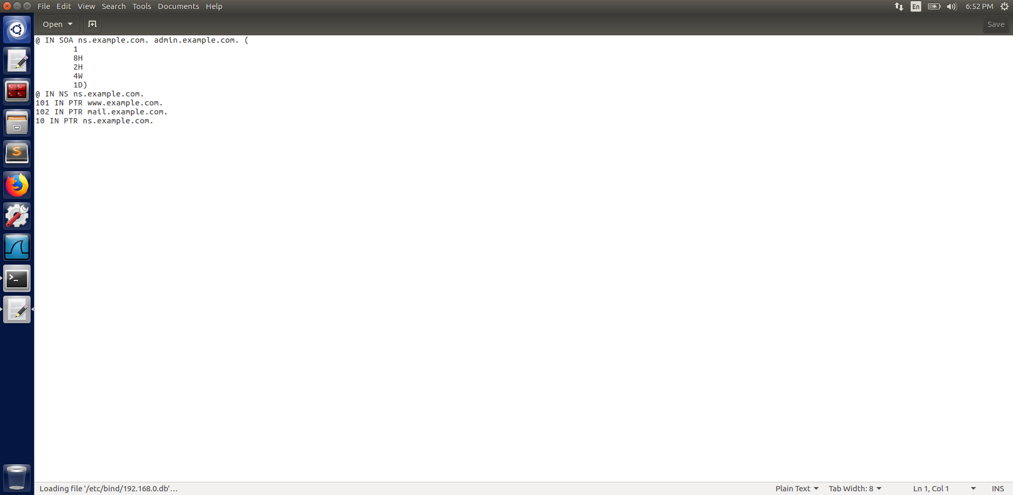

**Step 4 : Restart the BIND server and test**

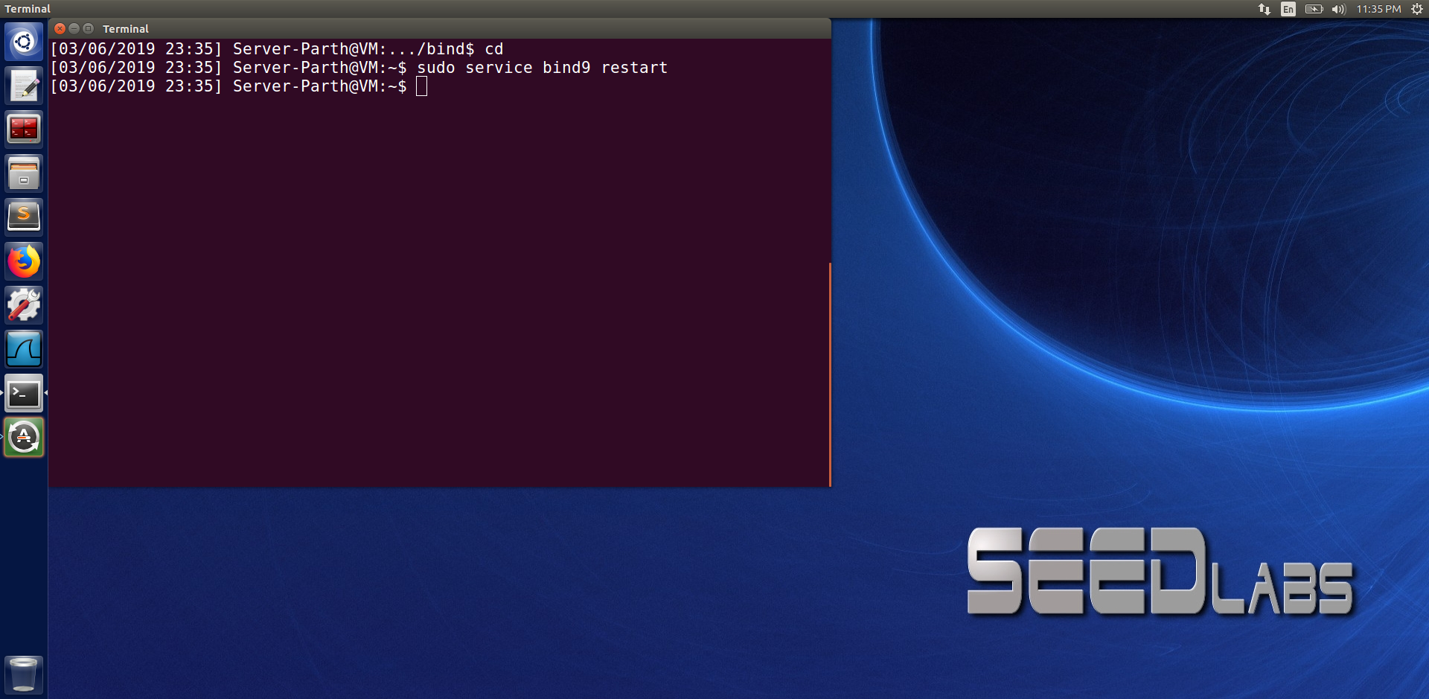

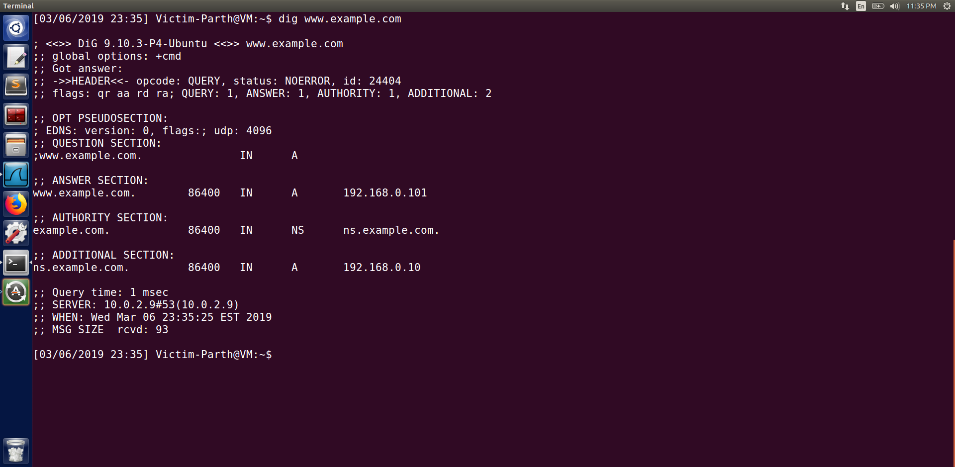

In the 1st step of this task we first create a zone for forward lookup and another zone for reverse loopkup. And then in step 2 & 3 we create the forward and reverse lookup zone file for the same. Now in the server machine we restart the server. And then use the dig command to verify that the changes made were successful. We can see that when we compare the IP that we defined in the previous steps, we get exactly the same IP using the dig command.

**Task 4: Modifying the Host File**

**Before the Attack:**

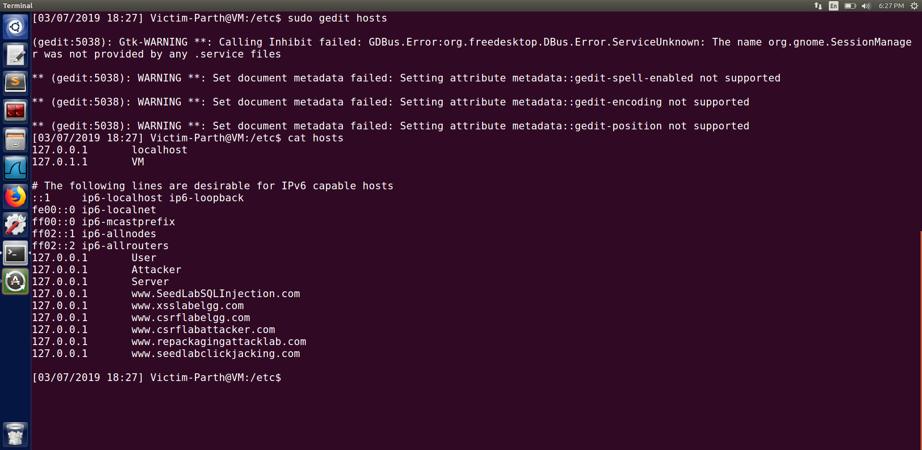

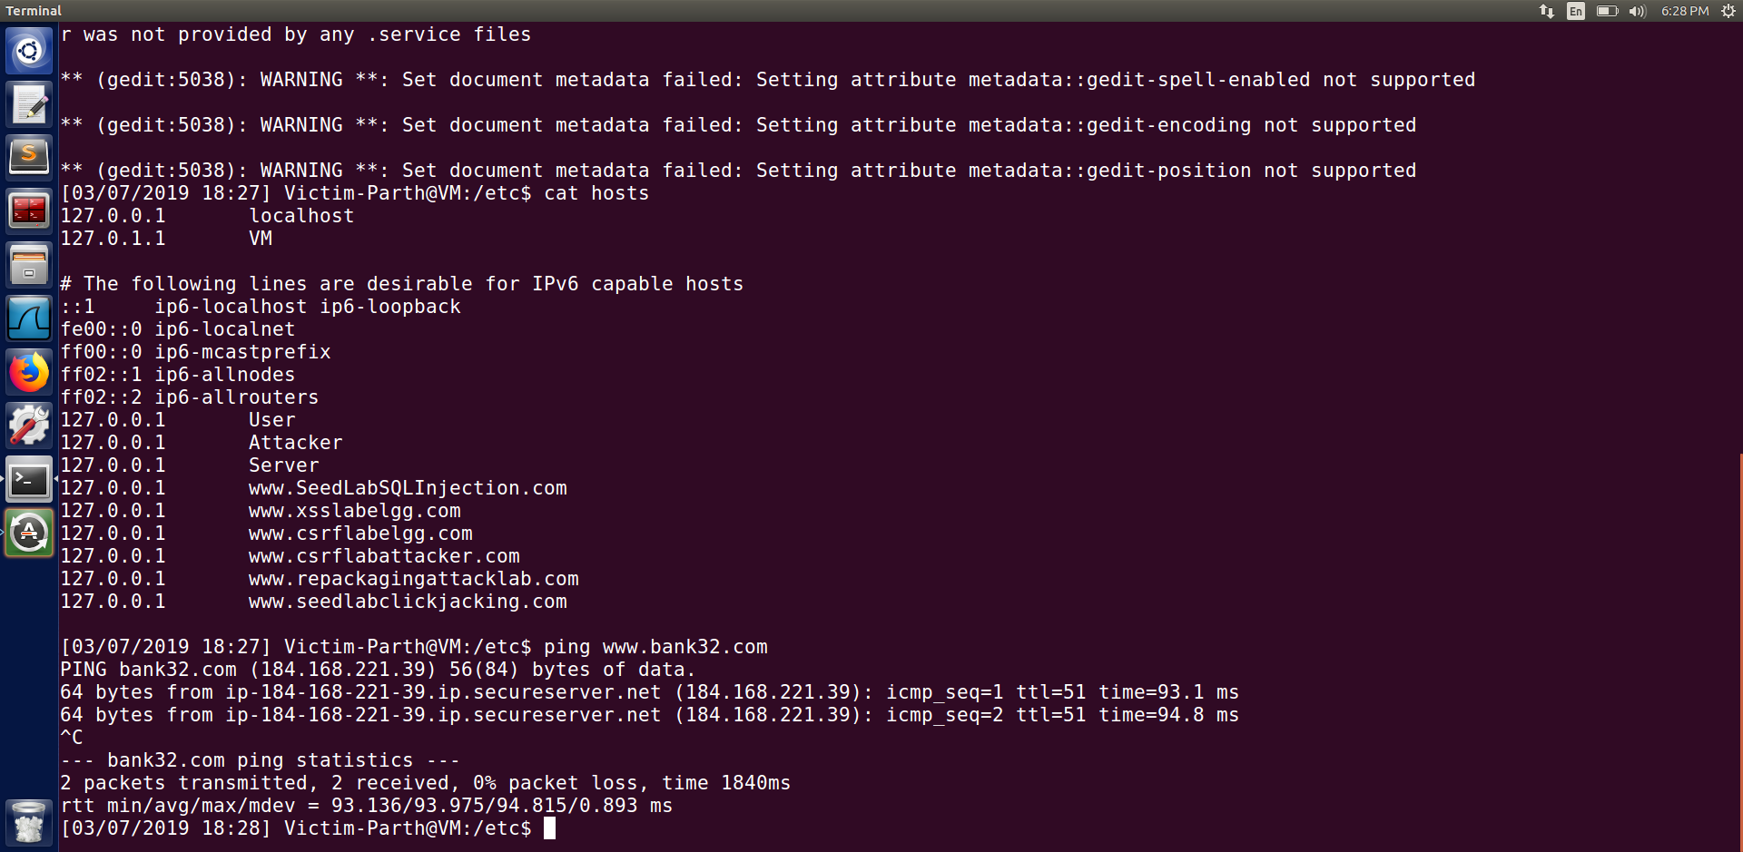

In this task before executing the attack we first make sure that we have not added any content to the hosts file. We use the command ‘cat hosts’ to see the result. As seen from the above screenshot that www.bank32.com is not added to the file. Now we ping [www.bank32.com](http://www.bank32.com). We can see the actual IP address of it.

**After the Attack :**

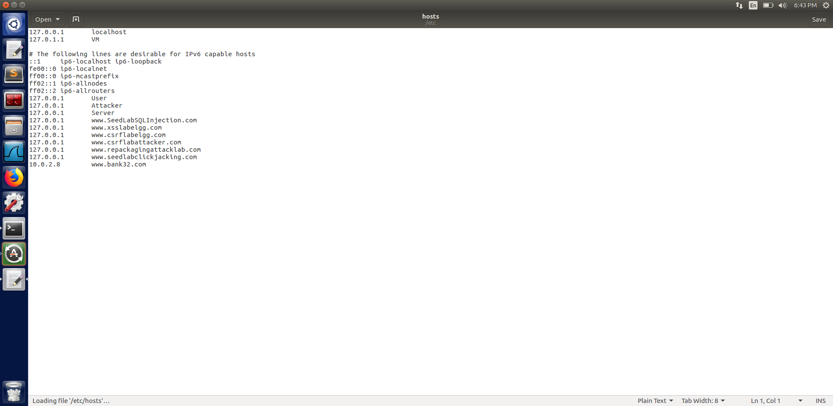

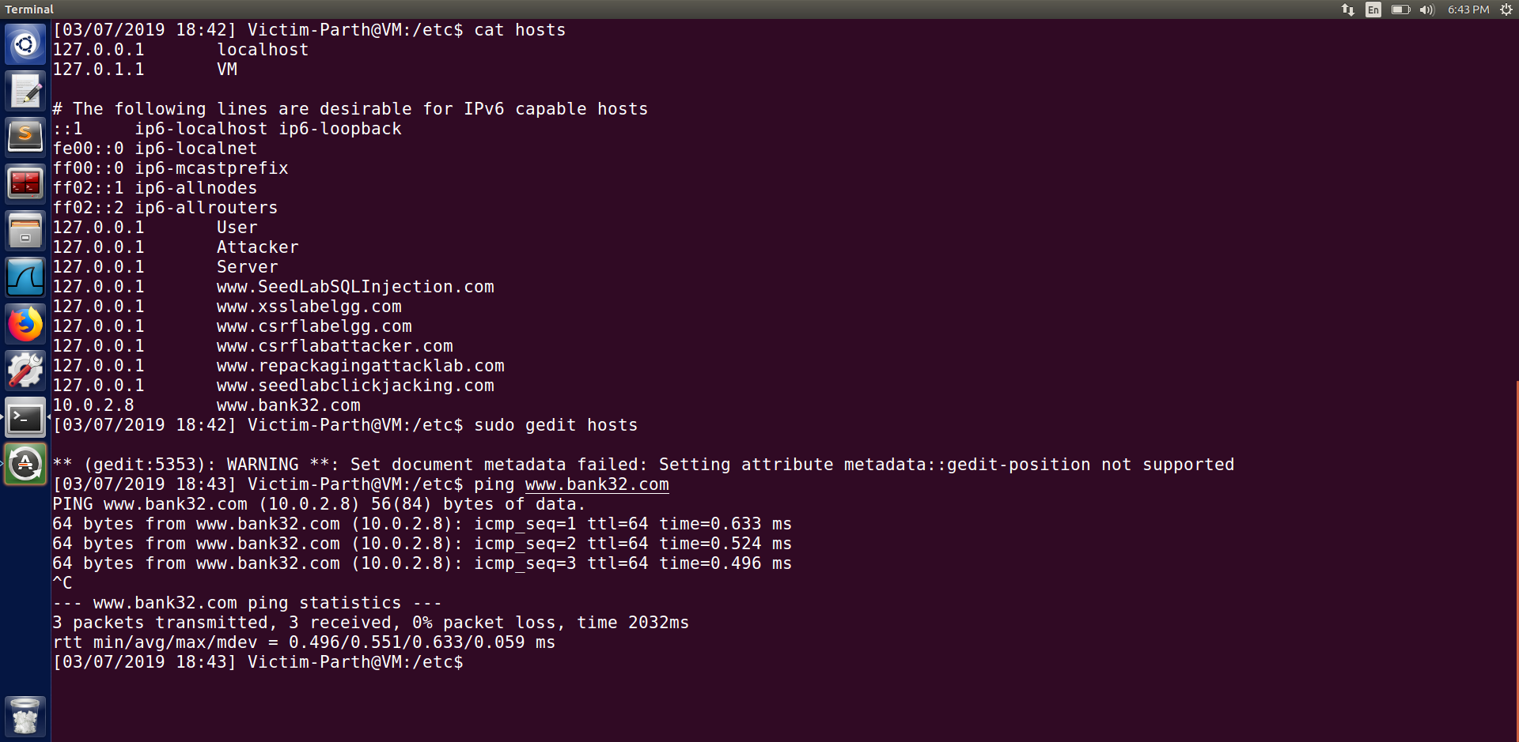

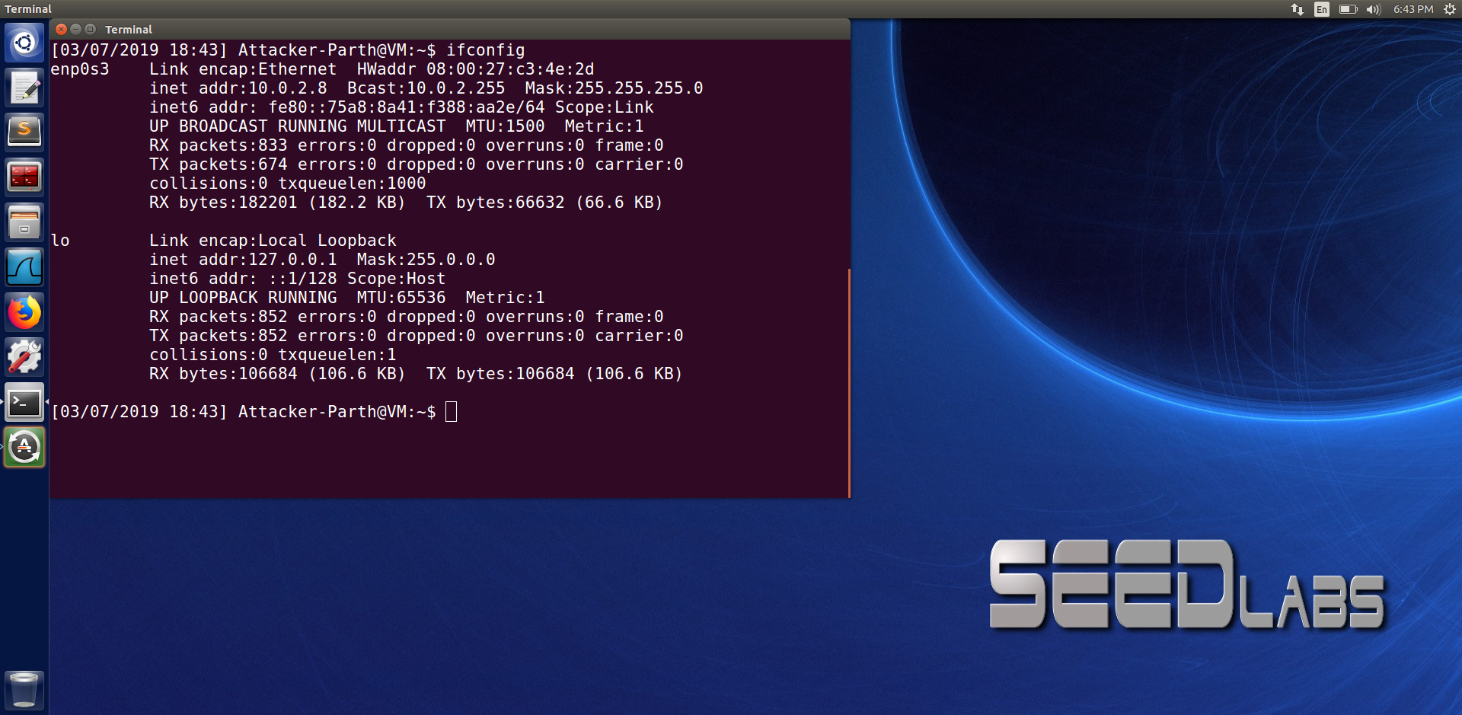

Now to execute the attack we first modify the hosts file and change the IP of [www.bank32.com](http://www.bank32.com) to 10.0.2.8. To make sure that the changes were successful we used the cat command and can see that the IP for [www.bank32.com](http://www.bank32.com) is defined.

And then, we ‘ping [www.bank32.com](http://www.bank32.com)’ and we can see that the IP for [www.bank32.com](http://www.bank32.com) is now IP address ’10.0.2.8’. ( We can see the IP address of the attacker machine in the above screenshot)

This proves that if there is relevant entry in the hosts file then the user’s computer will not ask the DNS server. Which means that hosts file take the preference over the remote DNS lookups.

**Task 5 : Directly Spoofing Response to User**

**Before the attack:**

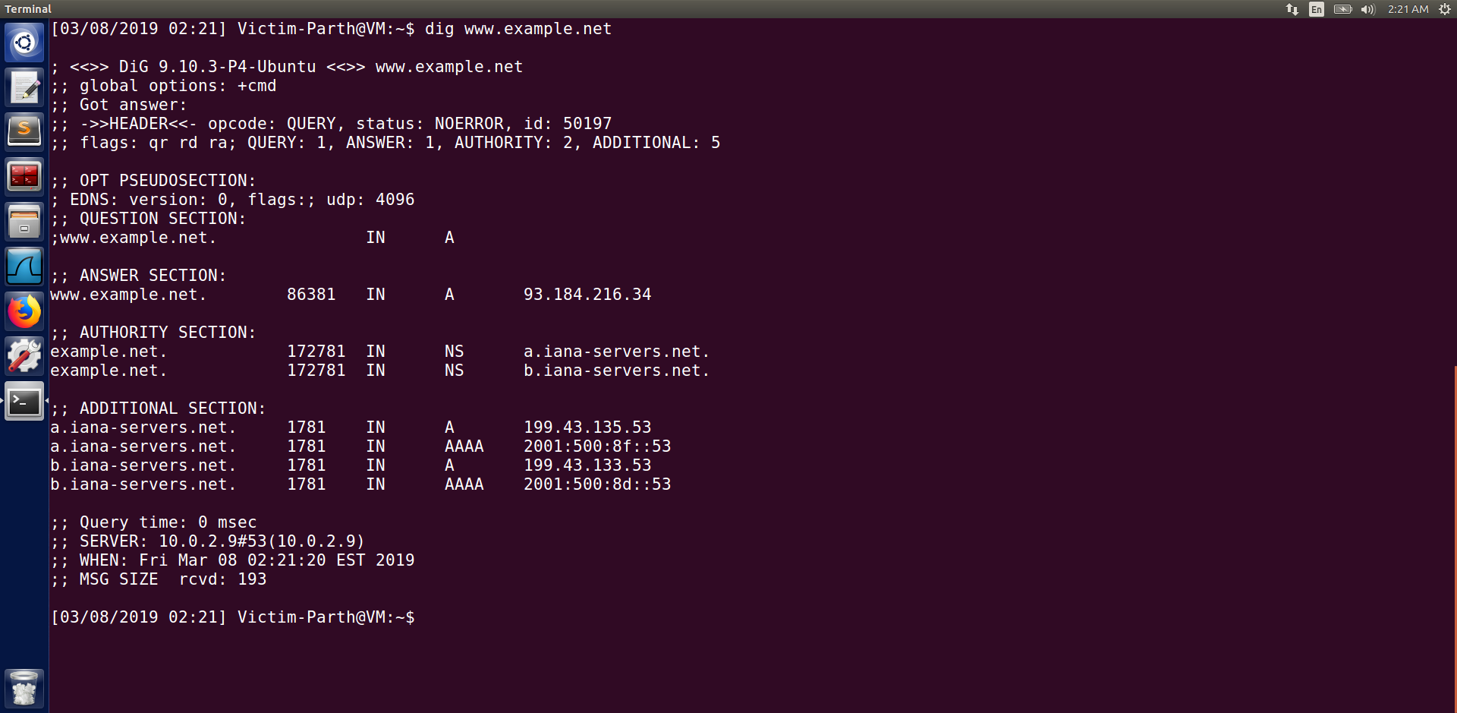

At first we make sure that the user machine is not compromised and no spoofing is done. We use the dig command to see the real IP of www.example.net.

**After the attack :**

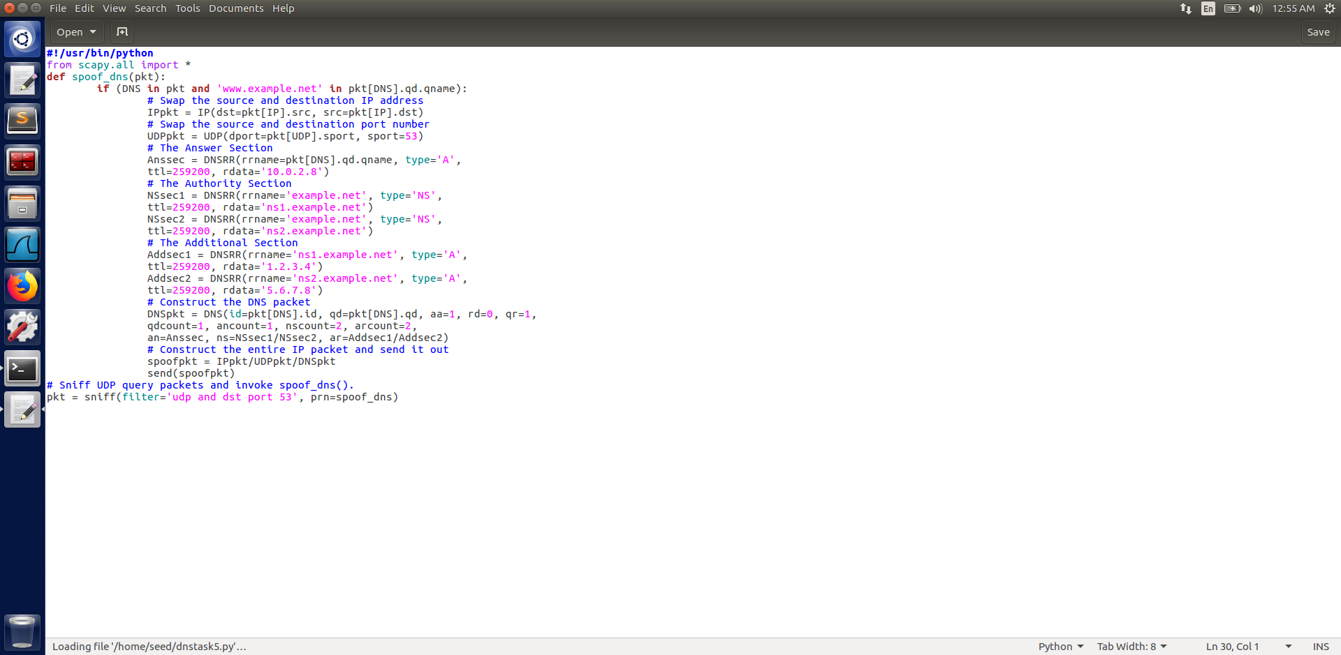

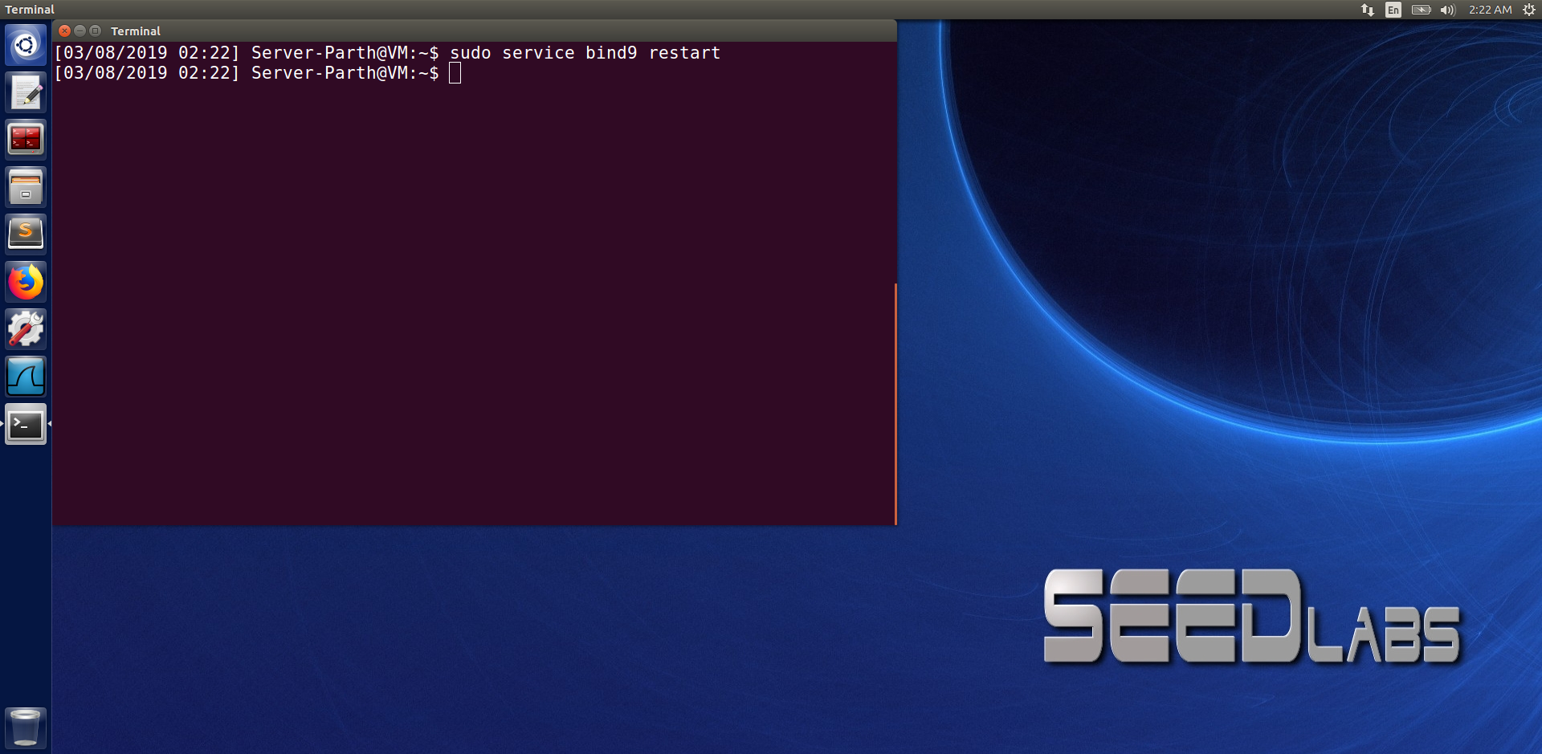

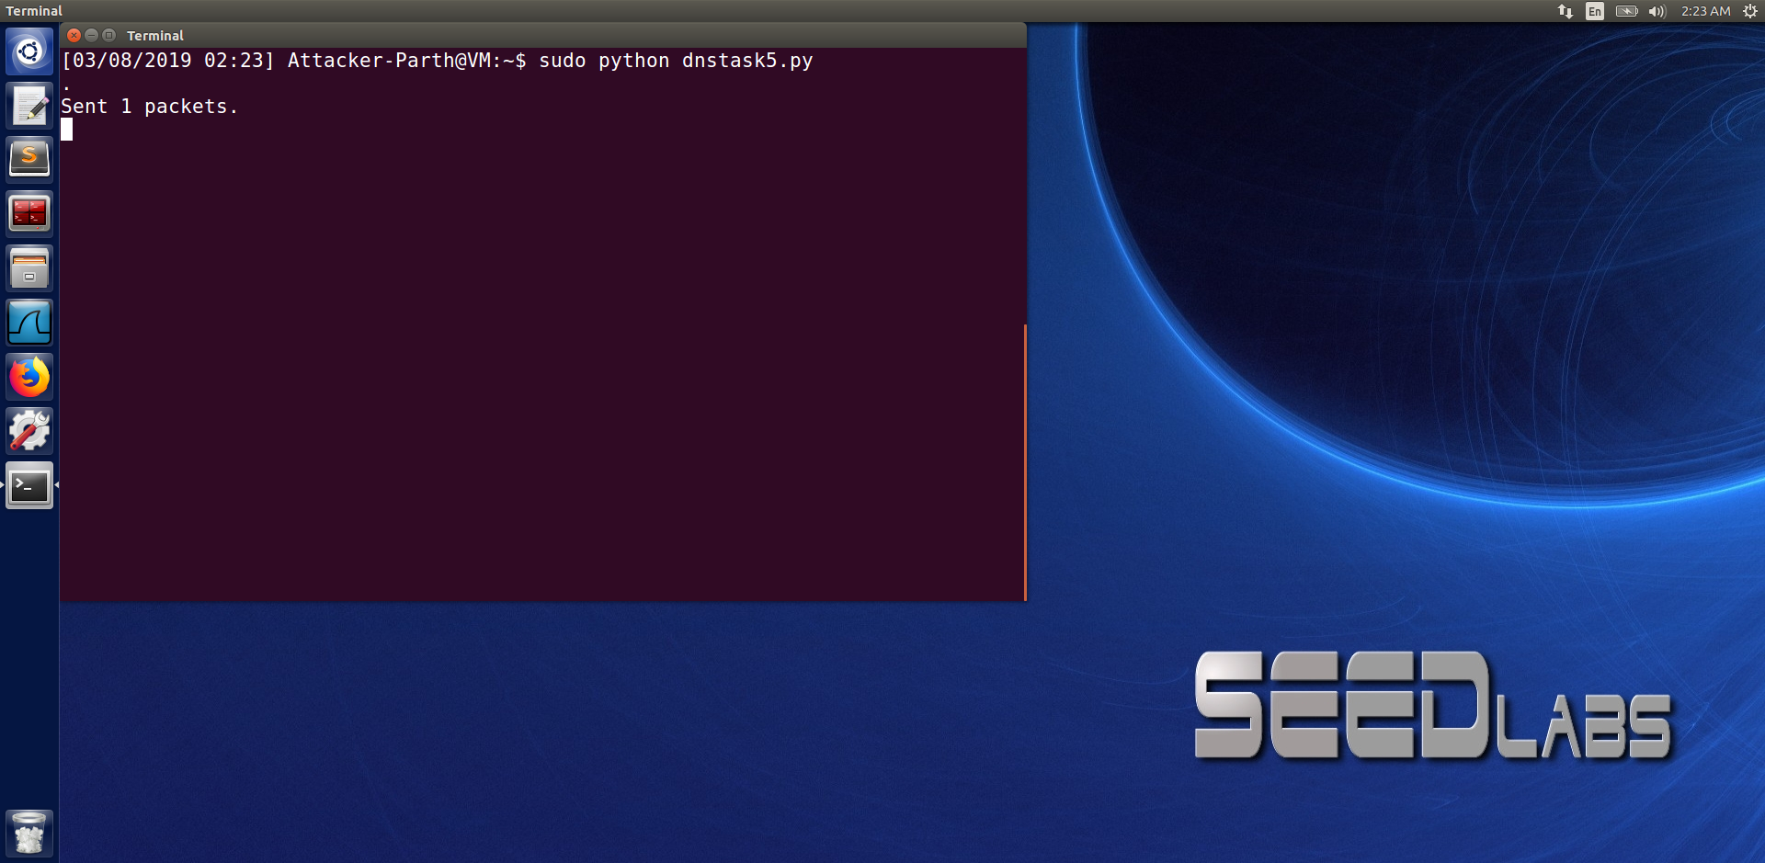

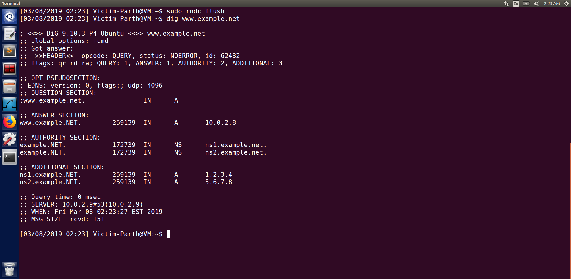

We execute the above code on the attacker’s machine. Then to issue a DNS query from the client machine we execute ‘dig [www.example.net](http://www.example.net)’ As soon as this DNS request is sent, the attacker will spoof the DNS request and will eventually be accepted by the user machine. When the attack is successful we can see the spoofed information in the reply.

When we compare the code with the spoofed reply we can see that the attack is successful, when compared with before the attack screenshot that contains the real IP.

**Task 6**

**Before The Attack :**



We can see from the above screenshot that the IP of the previous task is not cached as we used the ‘sudo rndc flush’ command to flush the contents of the cache.

**After The Attack:**

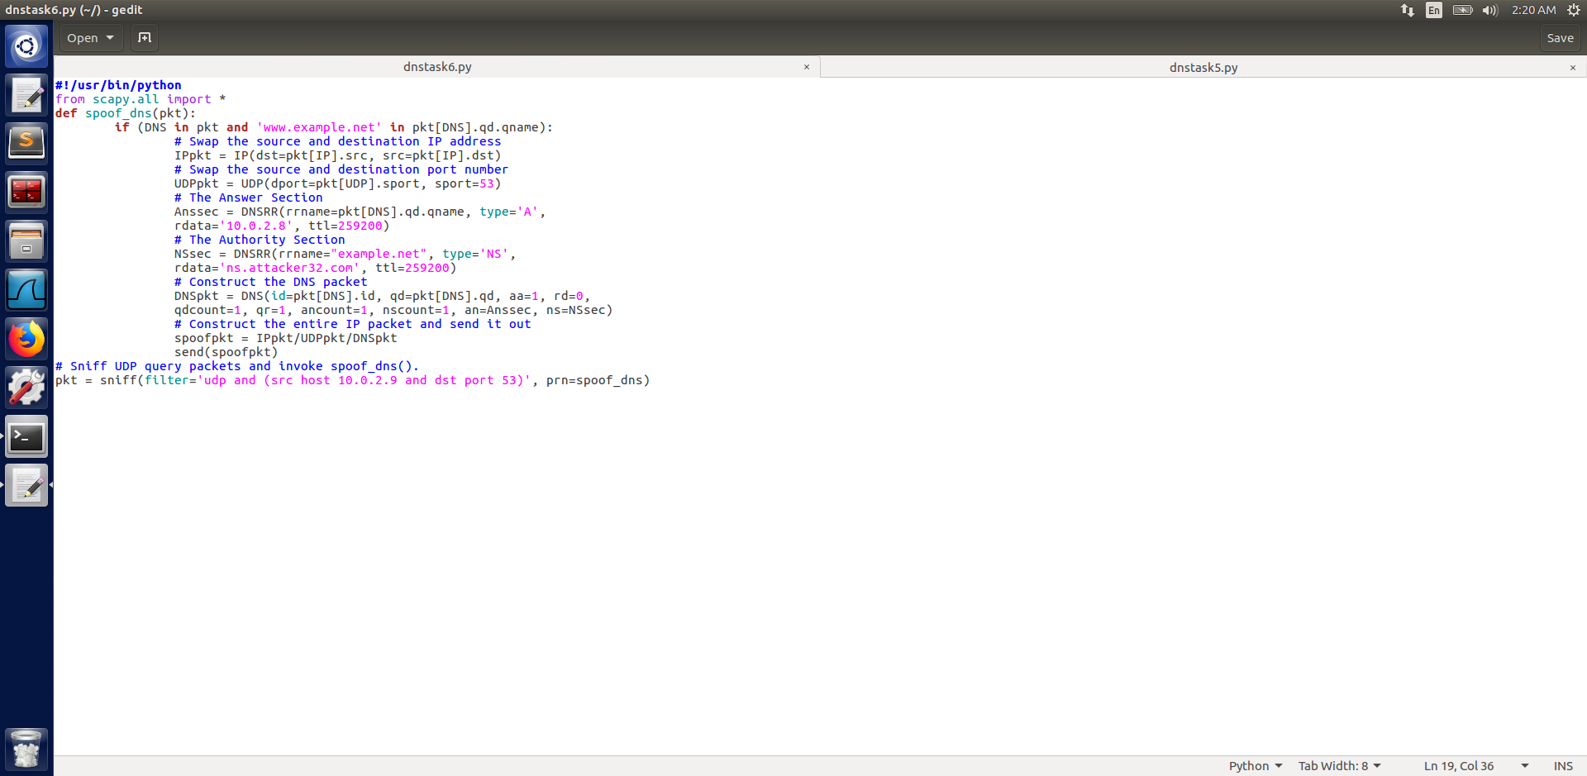

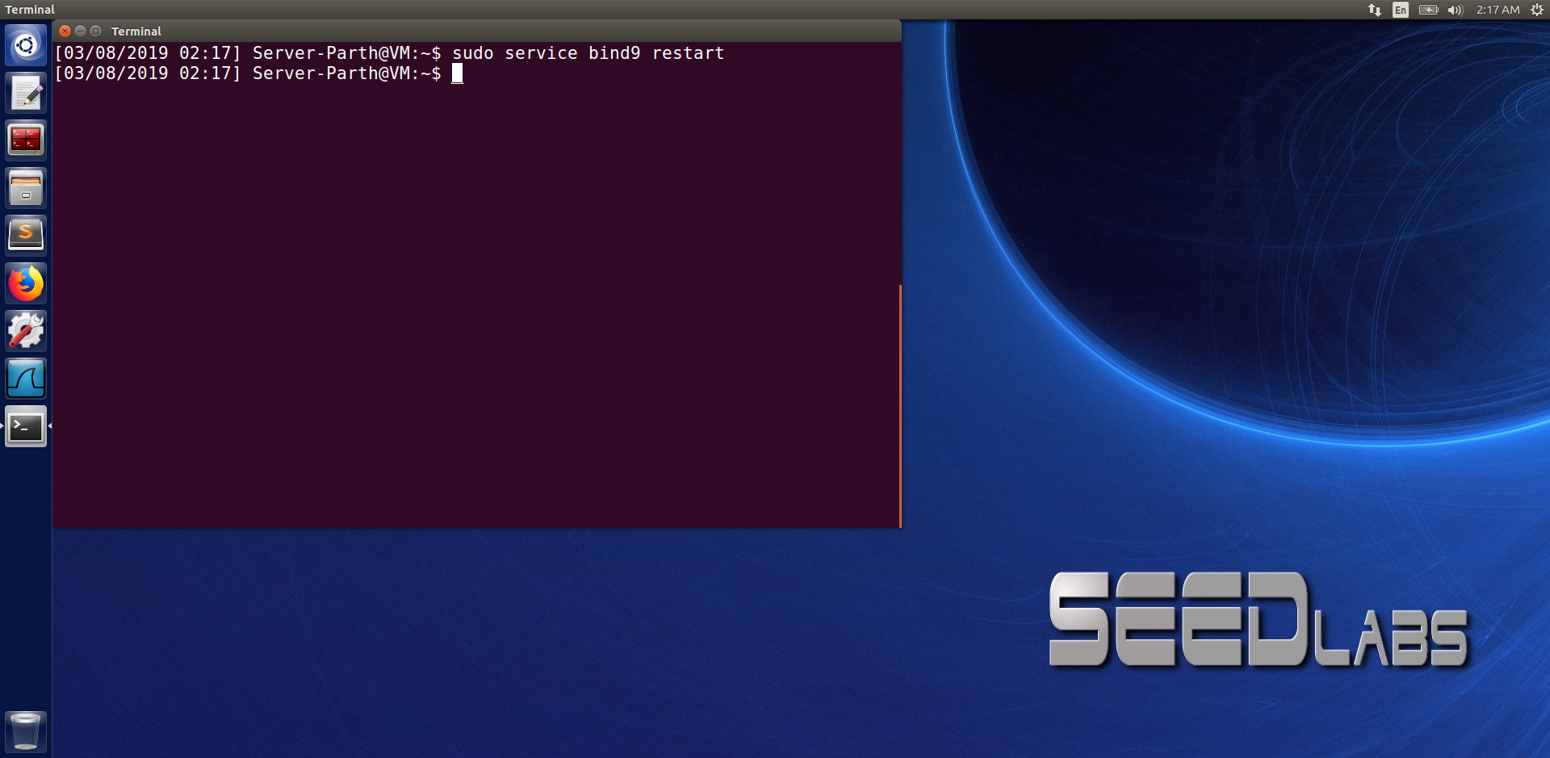

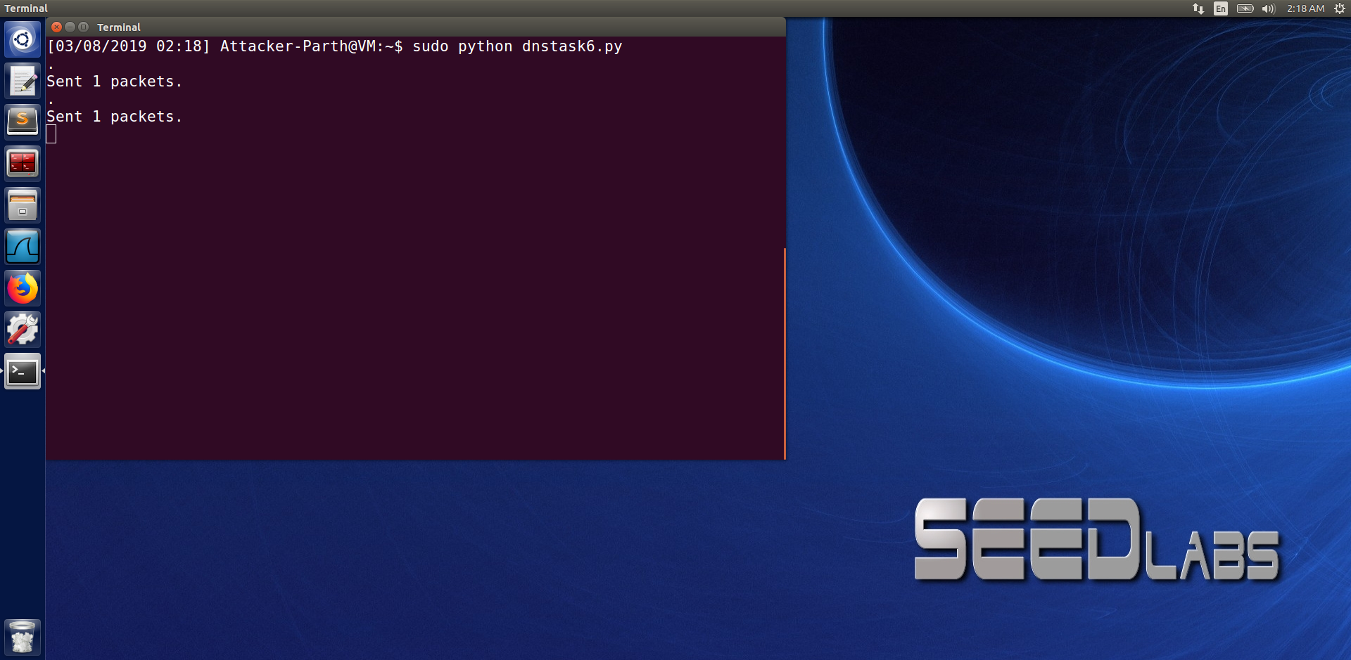

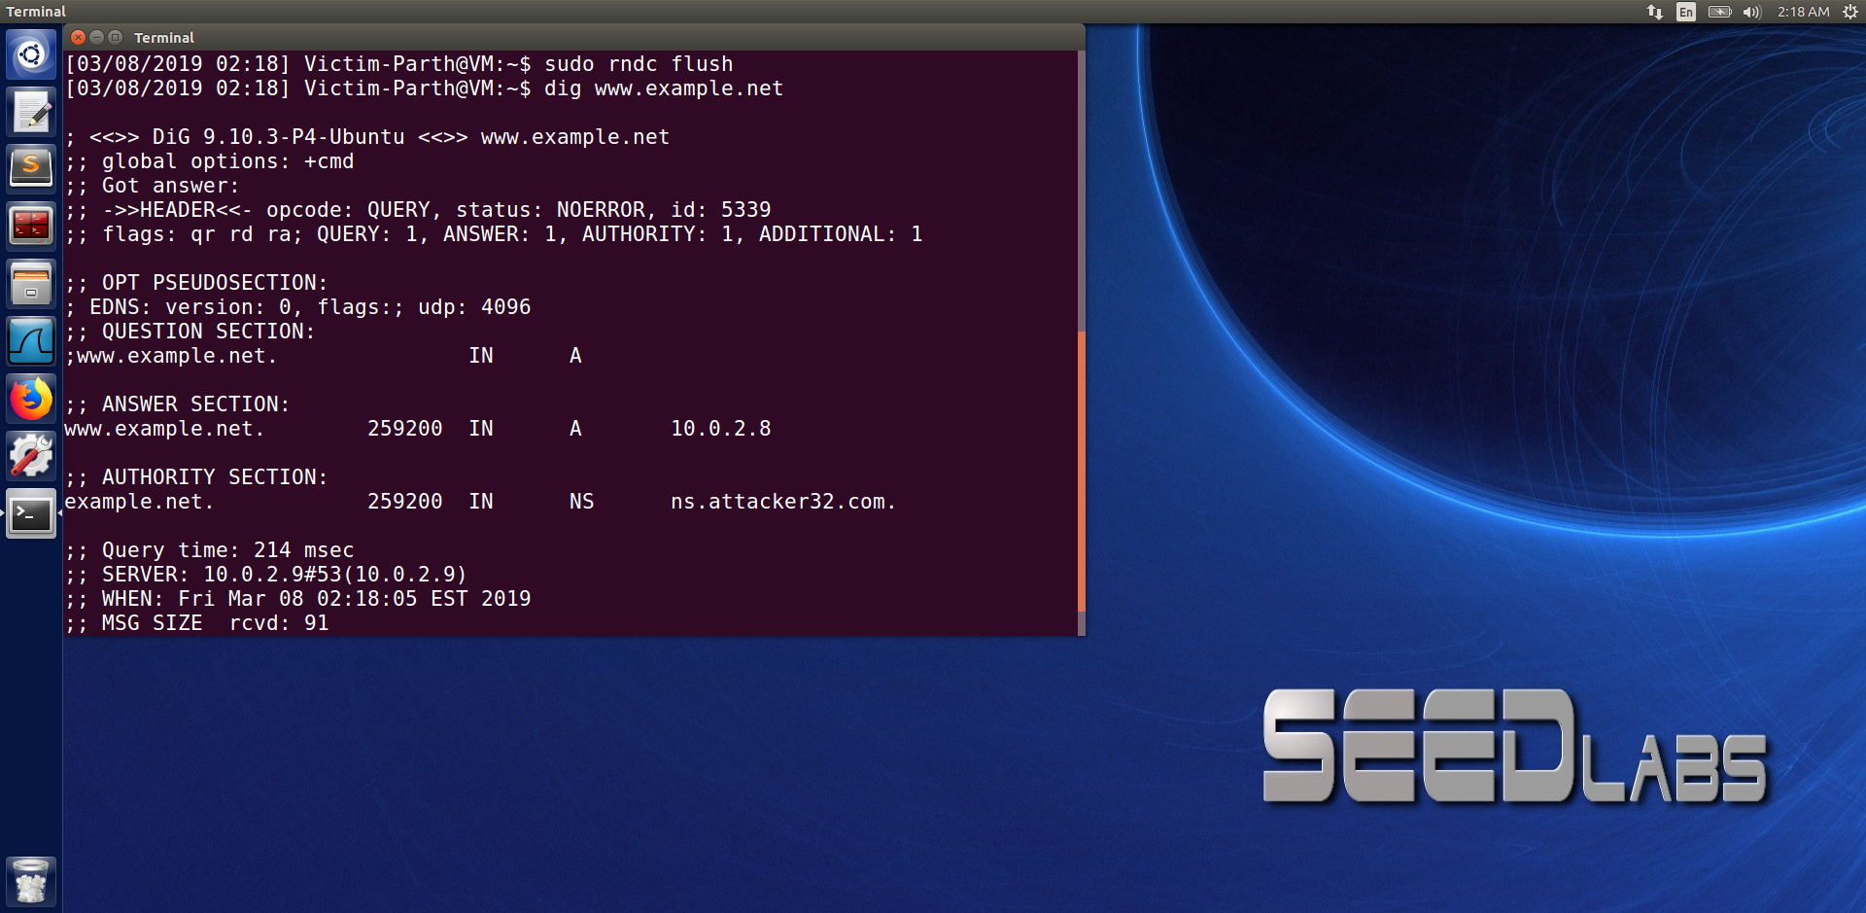

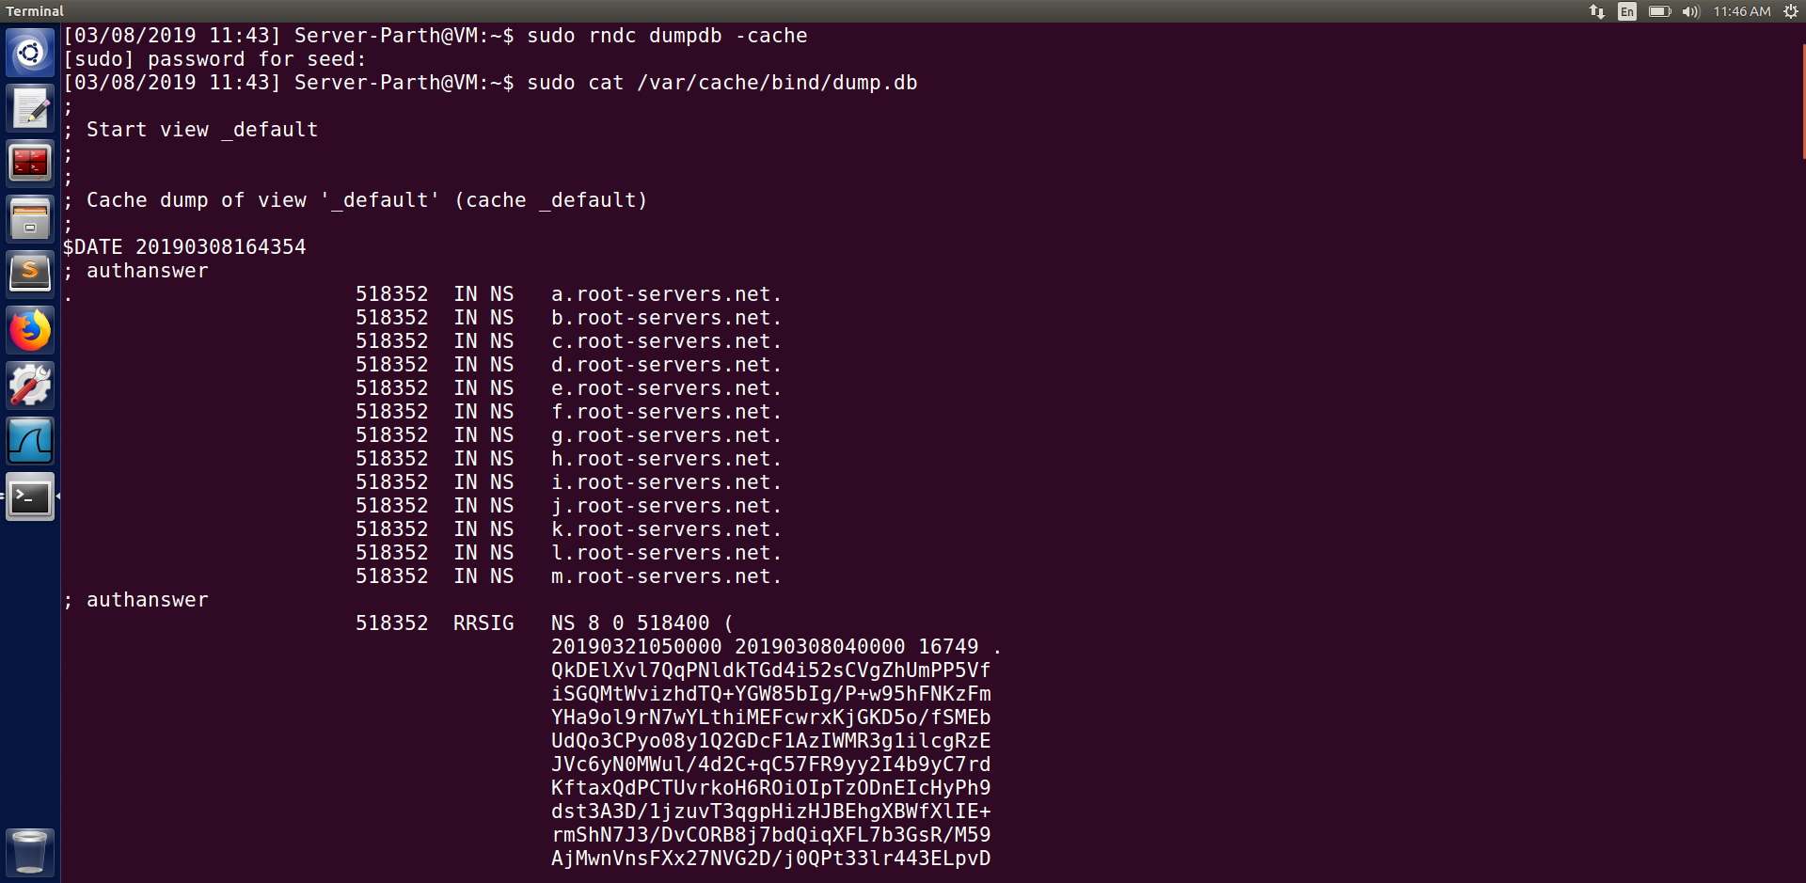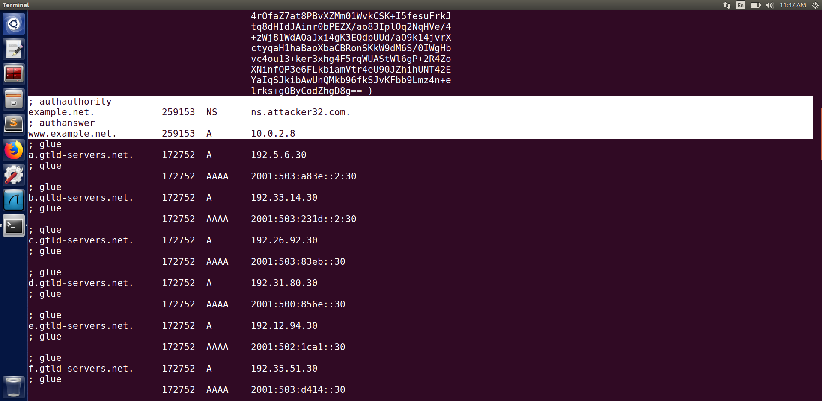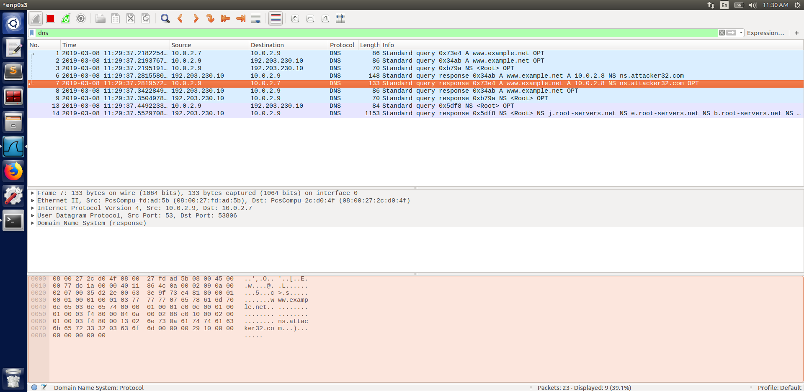

In this task we spoof the DNS server and therefore, change the filter part in the code to poison the server compared to the previous code.

We first restart the server as there were changes made in the code. Then, we execute the code on the attacker’s machine. After which we execute the command ‘dig [www.example.net](http://www.example.net)’ on the client. From the reply we can see that we were successful in spoofing the response. We can see from the wireshark screenshot that the server is poisoned. We also see the server’s cache and observe that the authority section and answer section was cached. And thus, we were successful in the attack.

**Task 7 : DNS Cache Poisoning: Targeting the Authority Section**

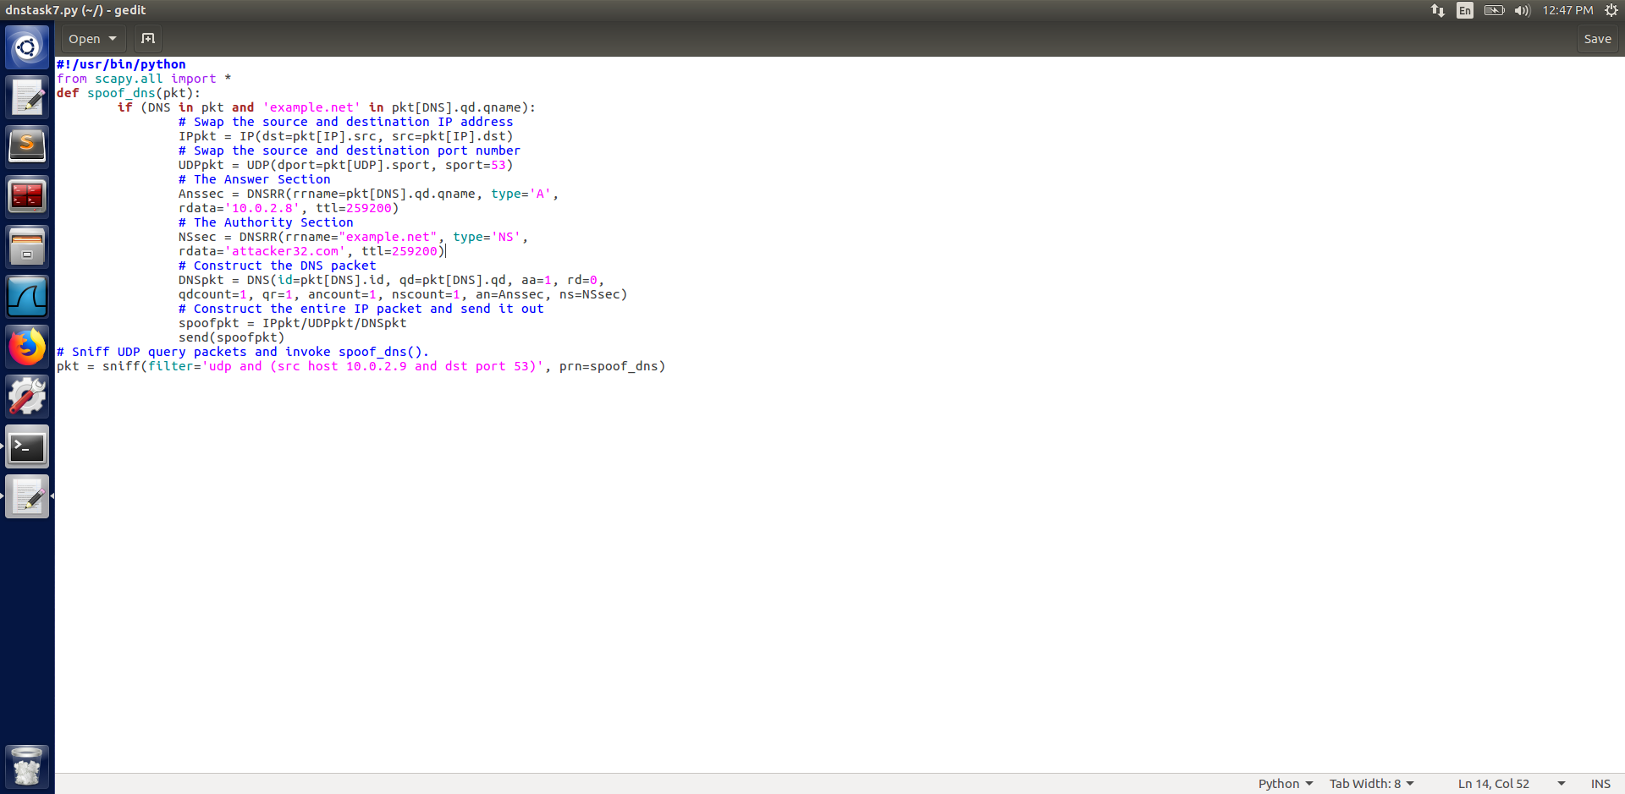

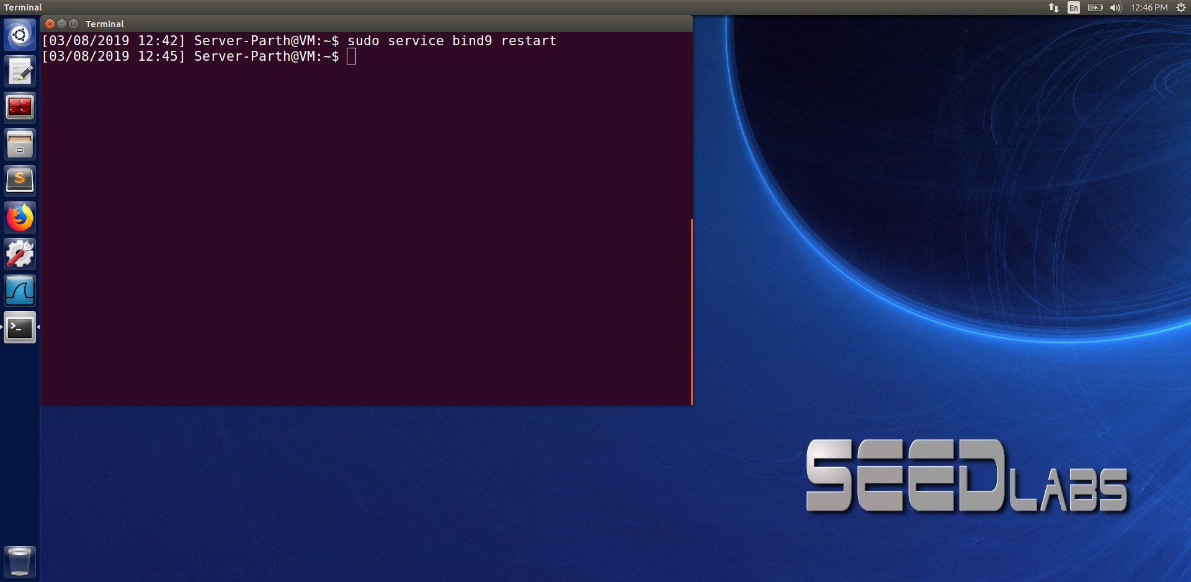

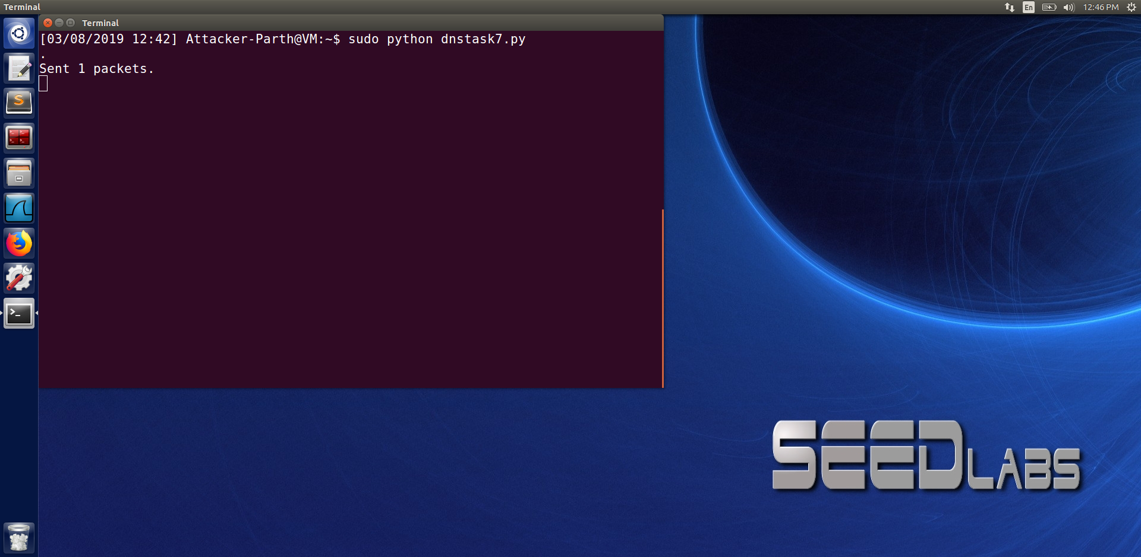

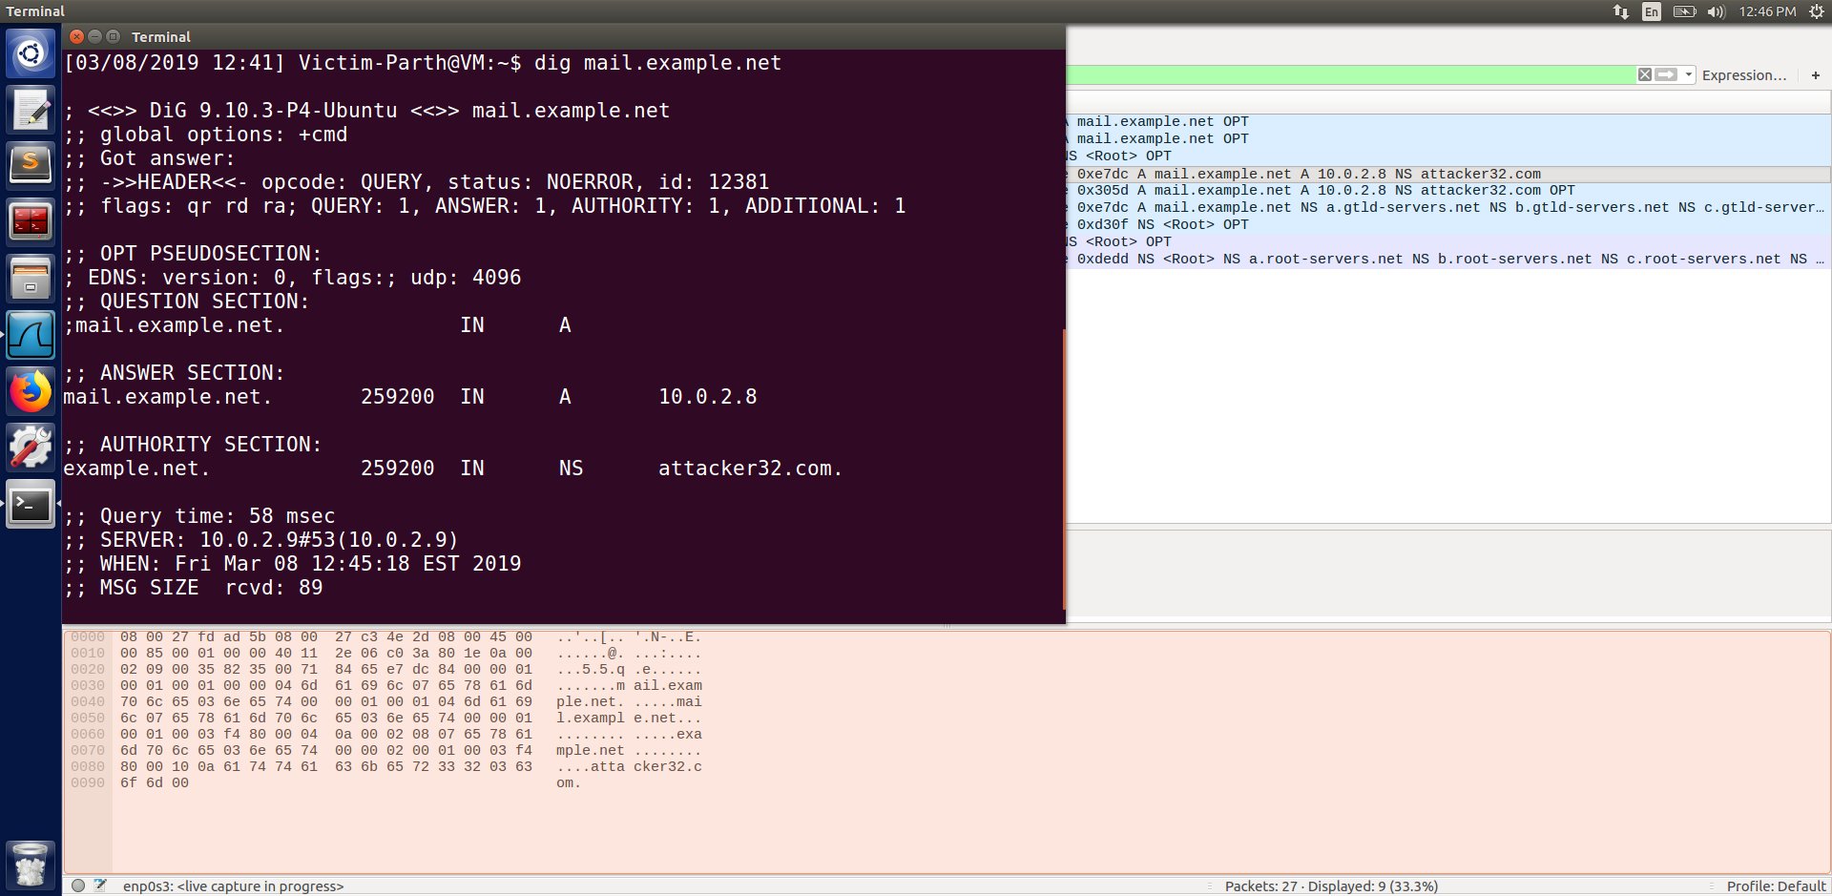

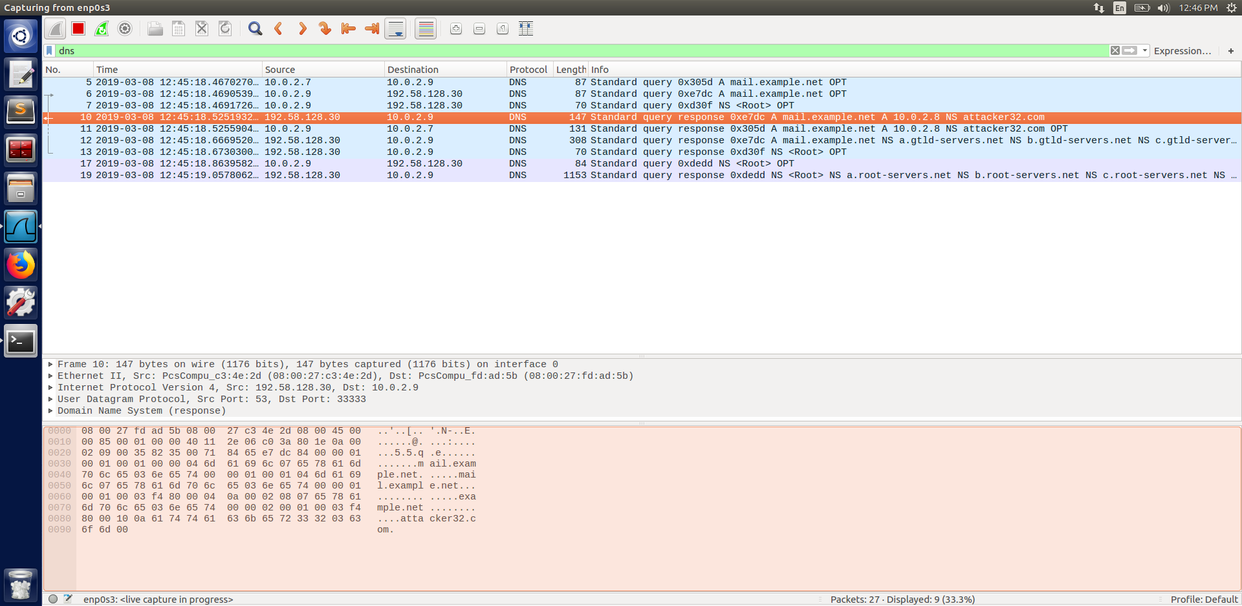

In the previous task we were only able to poison single hostname i.e., [www.example.net](http://www.example.net). Now to make a greater impact we change a part of the code where instead of ‘www.example.net’ we put ‘example.net’ in the code. Therefore, now when we try to dig any hostname in example.net for e.g., mail.example.net . We can observe the DNS query on wireshark, and can conclude that we were successful in poisoning the authority section.

**Task 8 : Targeting Another Domain**

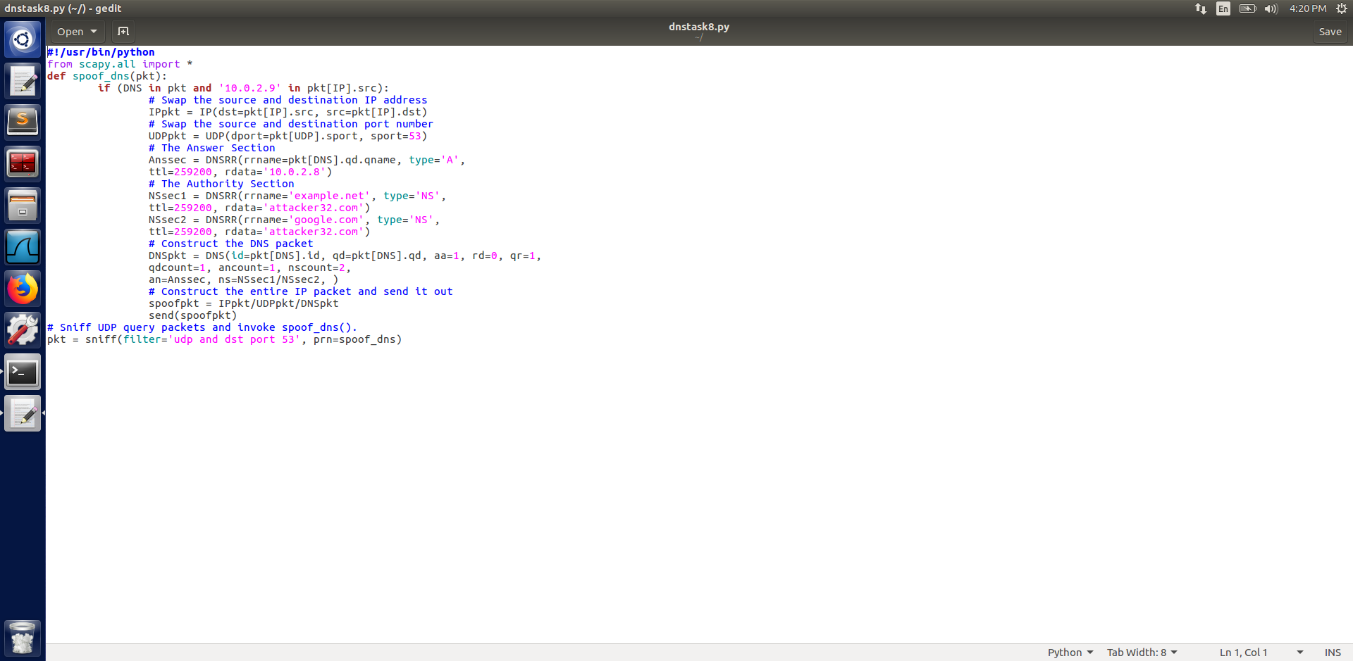

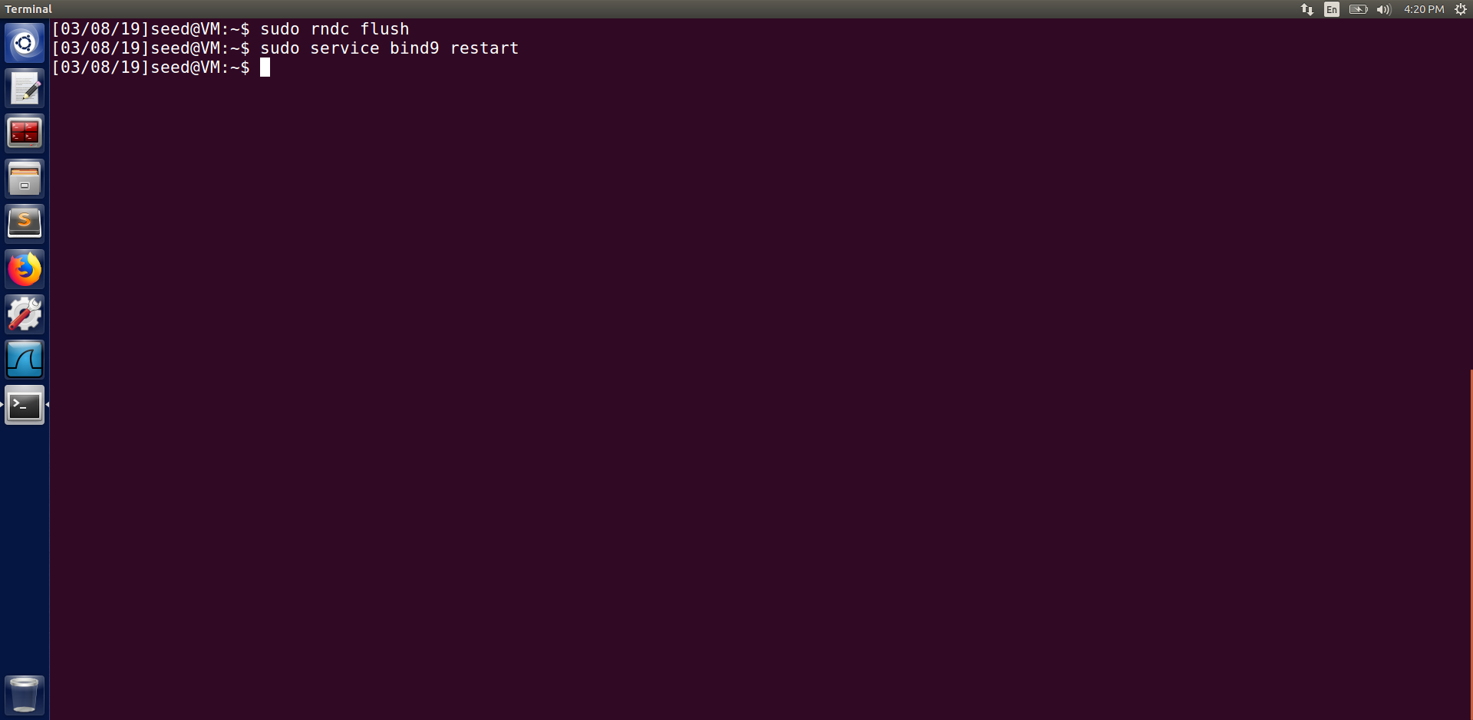

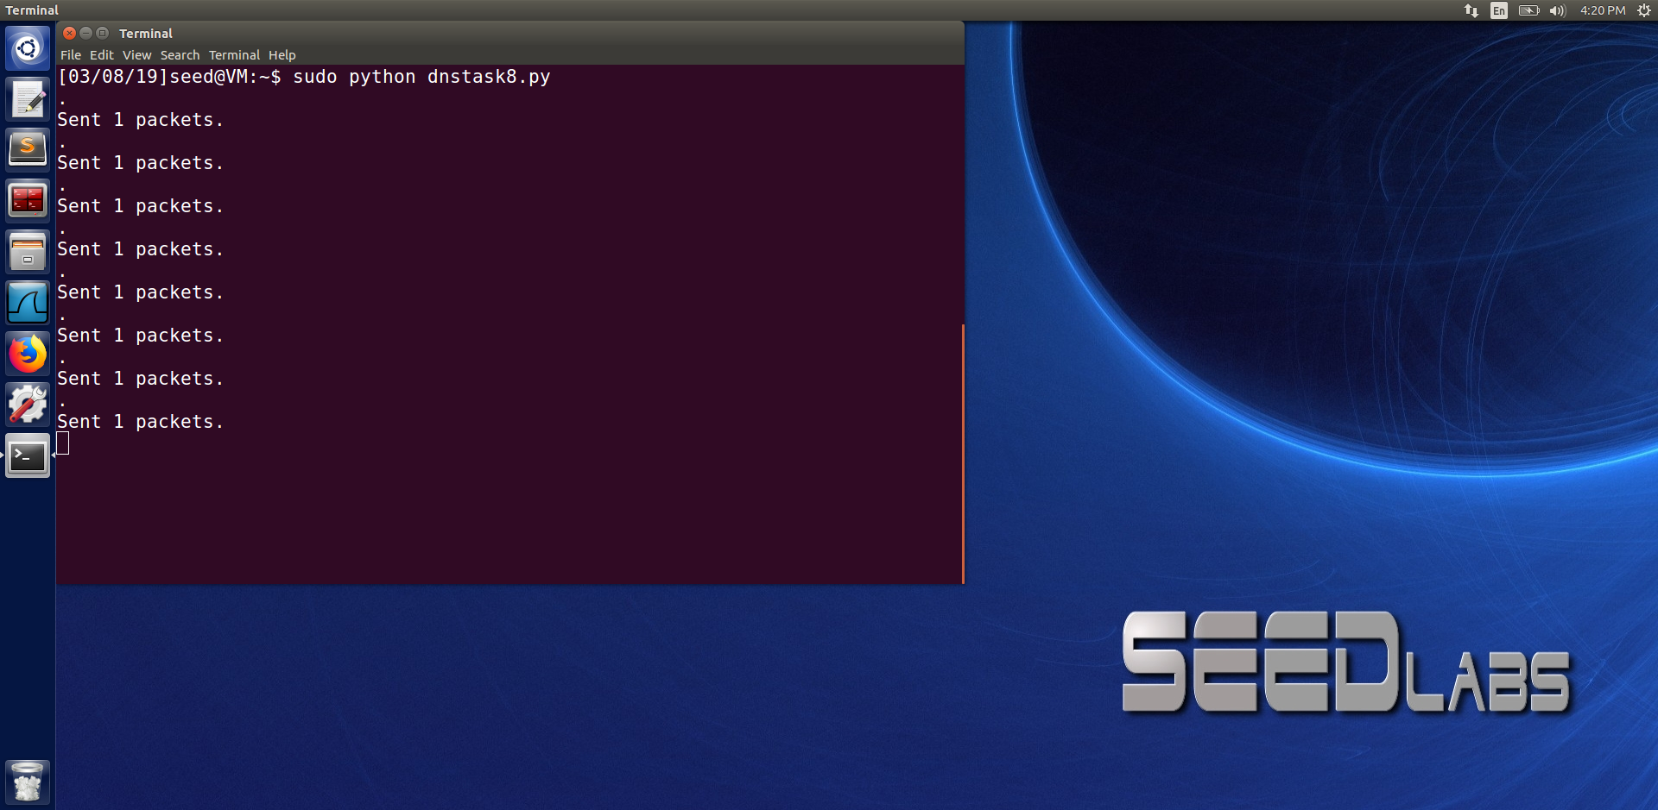

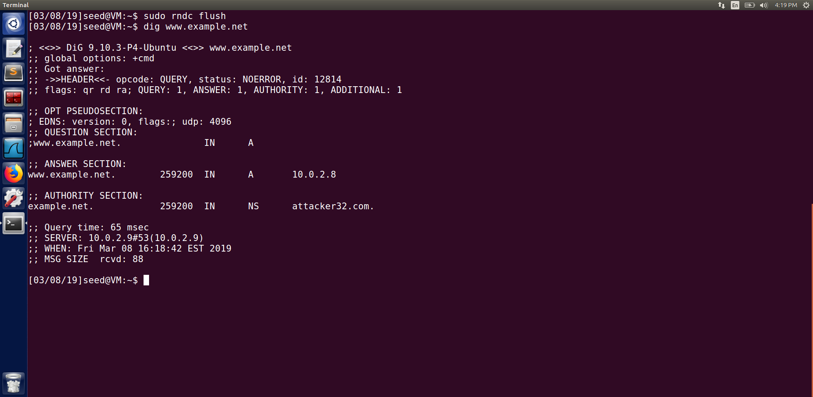

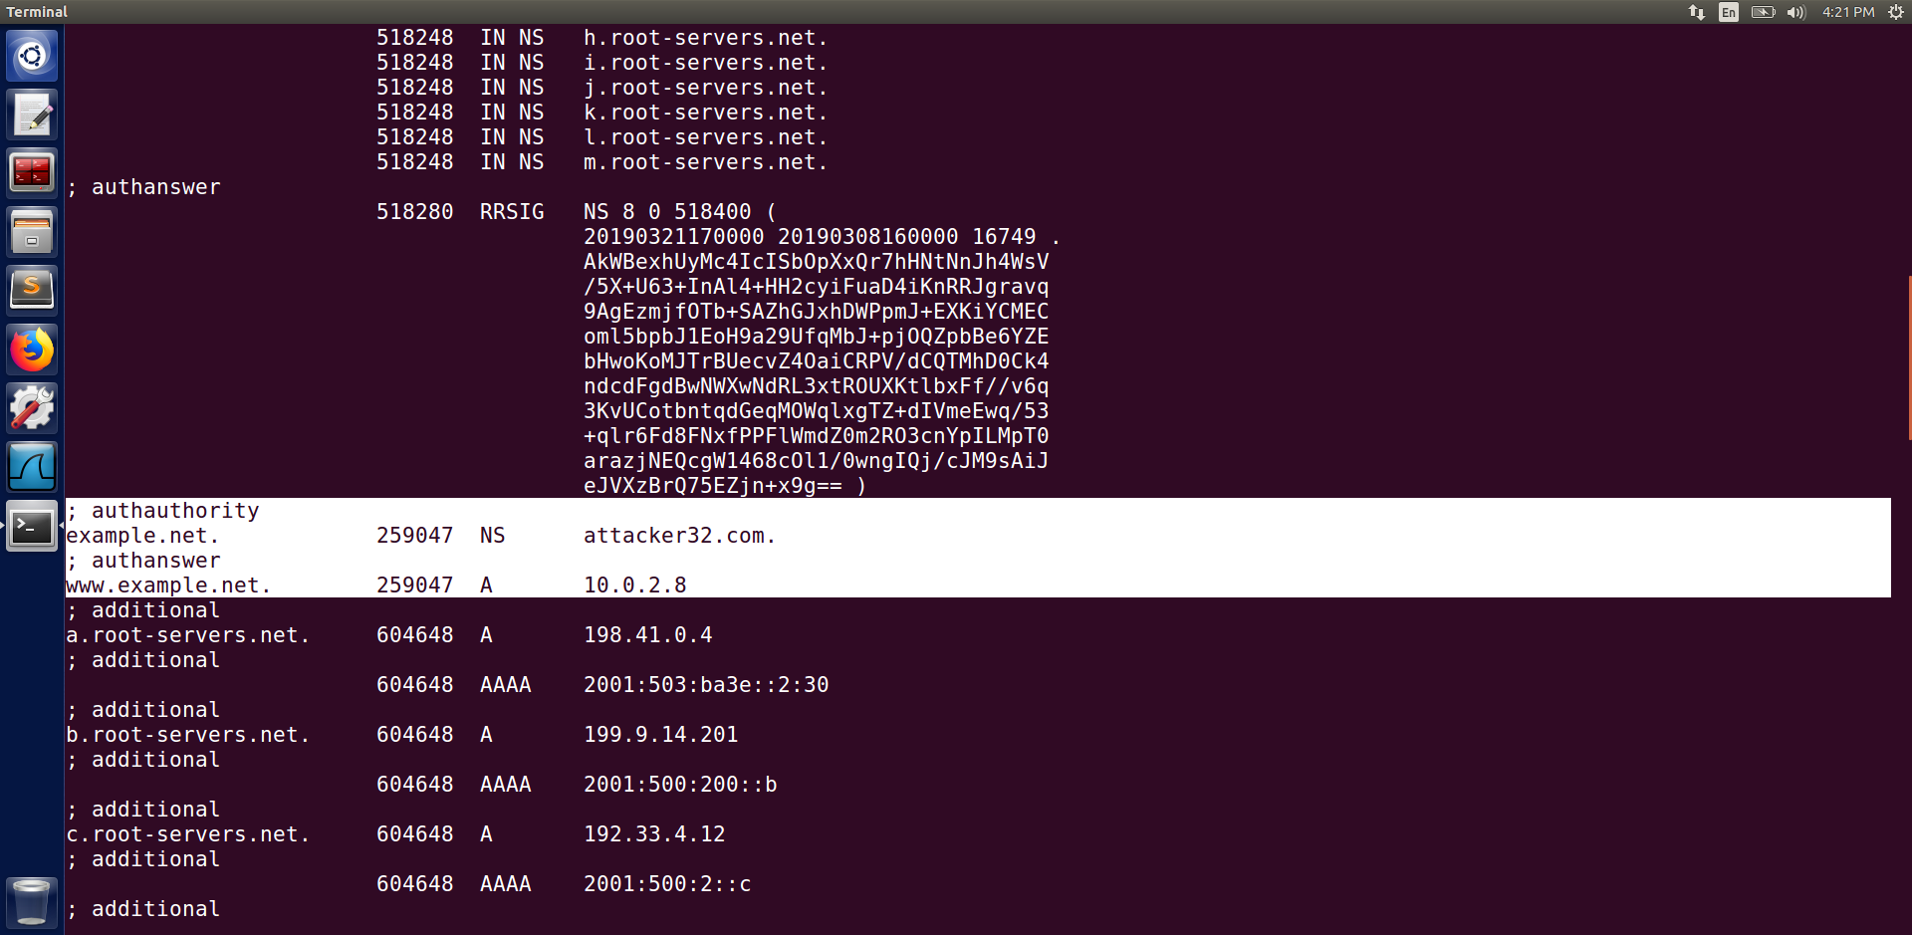

As seen from the code in the above screenshot we can see that in the authority section we added google.com whose nameserver (NS) is attacker32.com. We execute the command in the attackers machine and then use the dig command to see if we are successful in adding google.com in the spoofed response.

Once the dig command is executed we can see that in the authority section we were only able to add example.net and its NS attacker32.com. We check the server’s cache and we can see from the screenshot above that only the answer and authority of example.net is cached but not that of google.com. The hostname google.com was discarded from the authority section as it was not relevant to the question asked.

**Task 9 : Targeting the Additional Section**

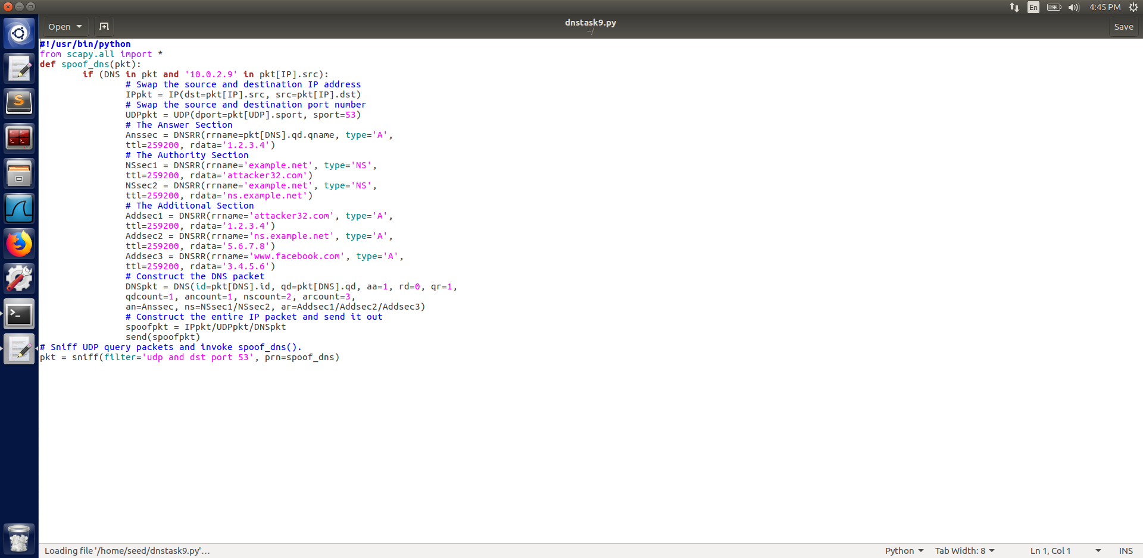

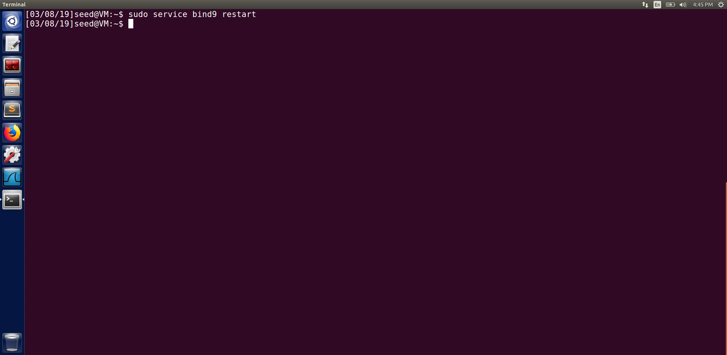

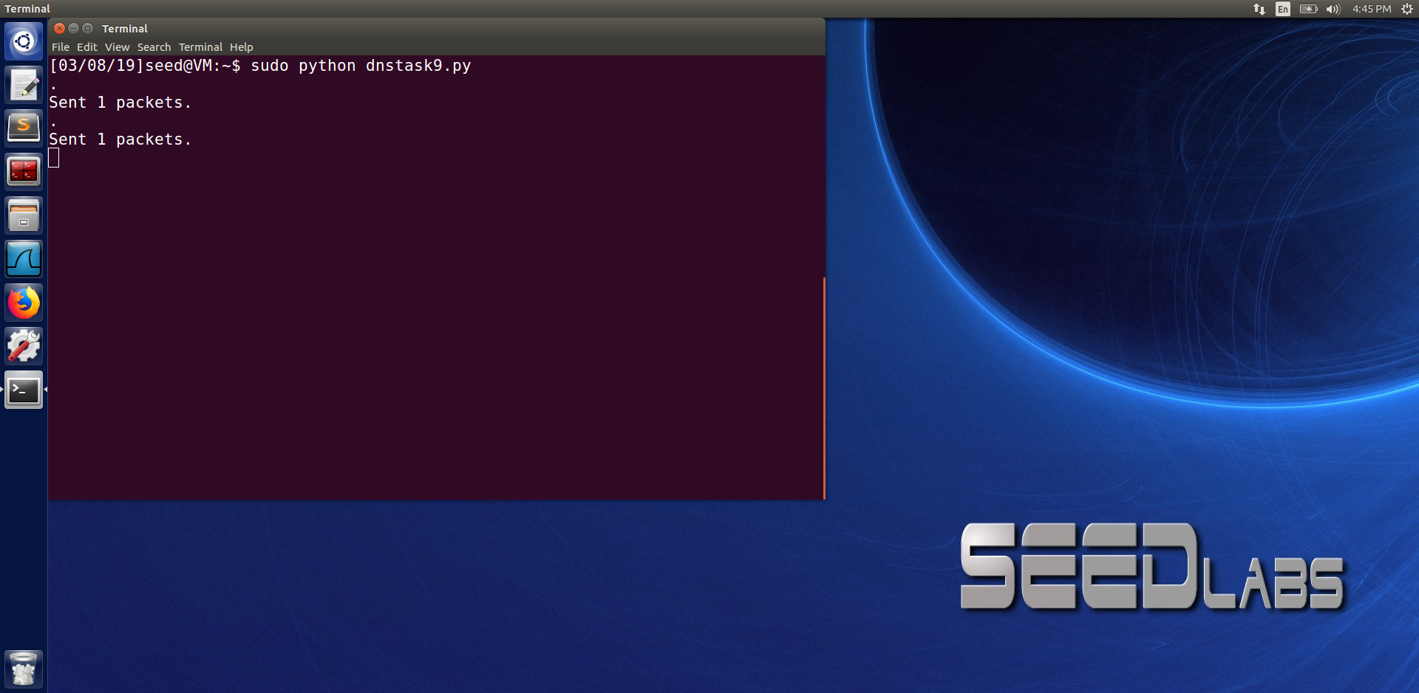

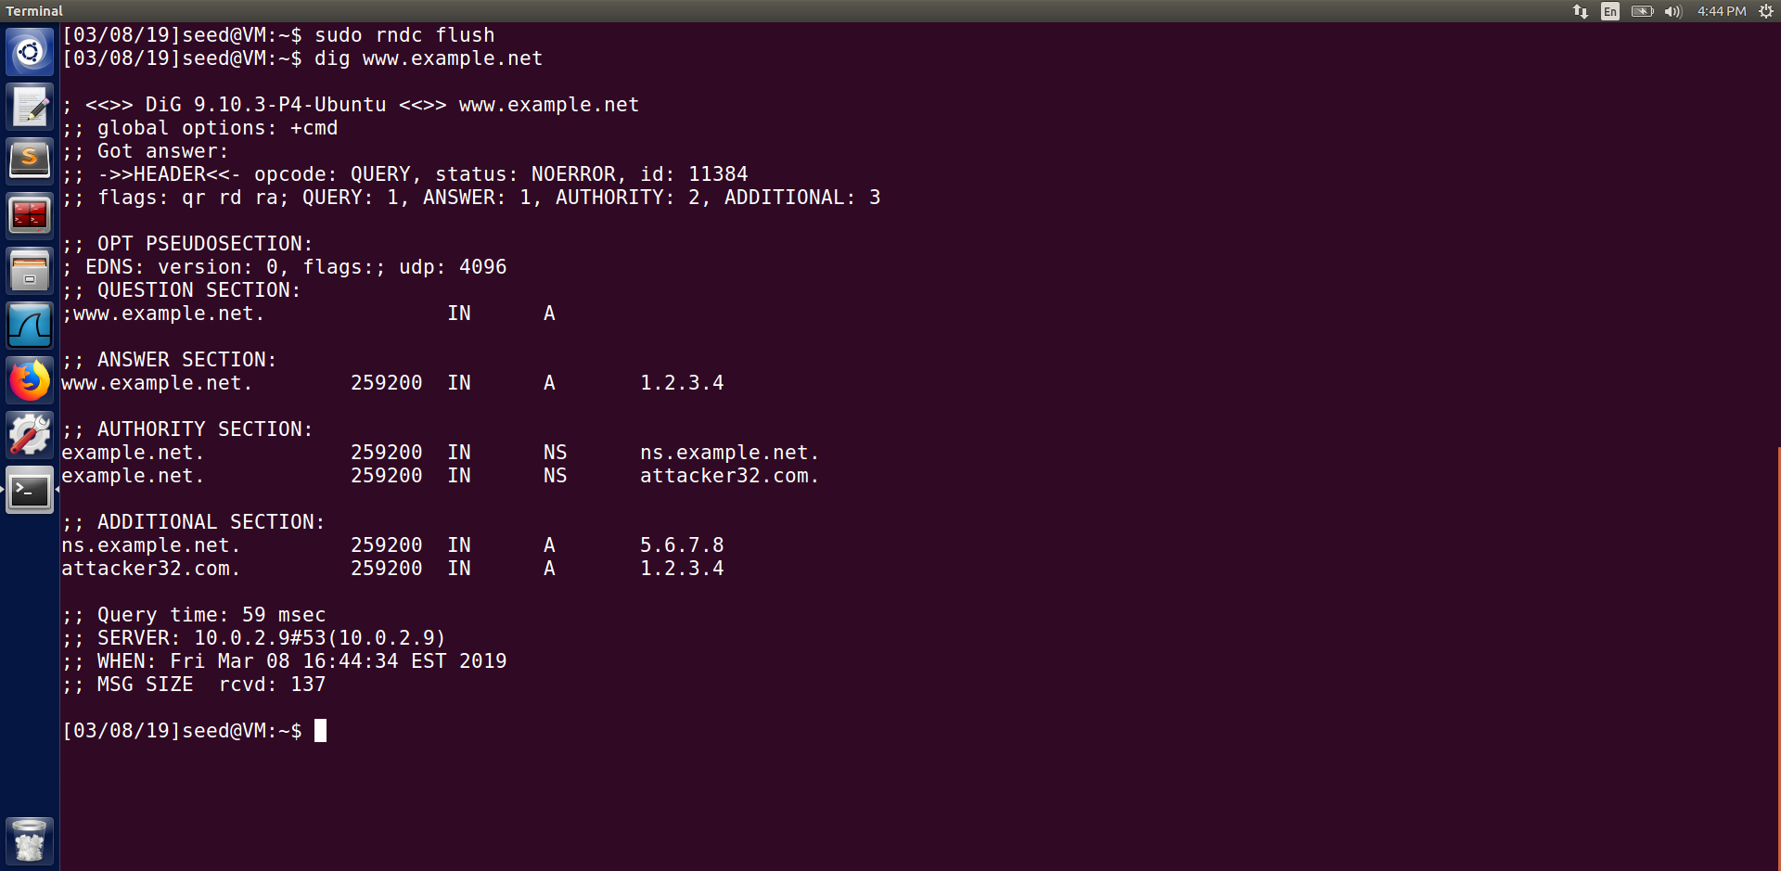

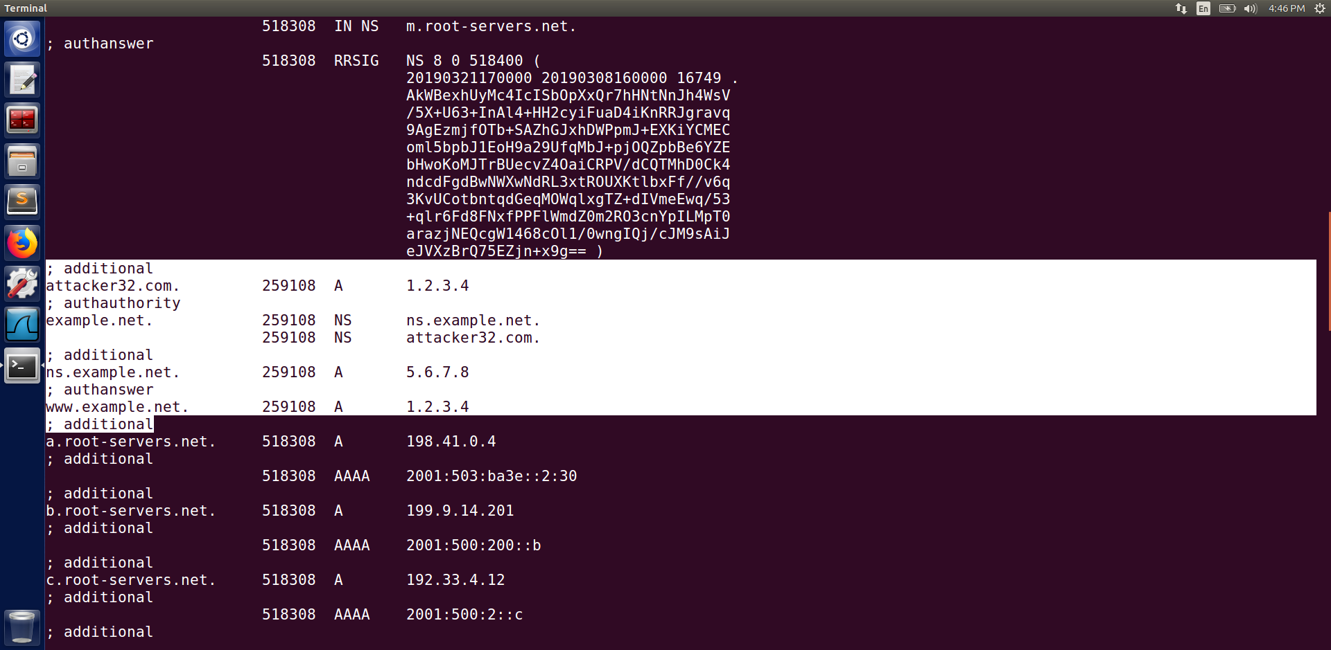

In this task we target the additional section that has information about the IP address of those appearing in the authority section. In the screenshot of the code we can see that we added 3 entries in the additional section out which 2 are relevant and the other was not. After executing the code we can see that only the relevant IP i.e., attacker32.com and ns.example.net and their corresponding IP’s were cached but the hostname ‘www.facebook.com’ and its IP ‘3.4.5.6’ was discarded as it was not relevant.